<https://www.youtube.com/watch?v=Q81RR3yKn30&list=PLblh5JKOoLUICTaGLRoHQDuF_7q2GfuJF&index=19>

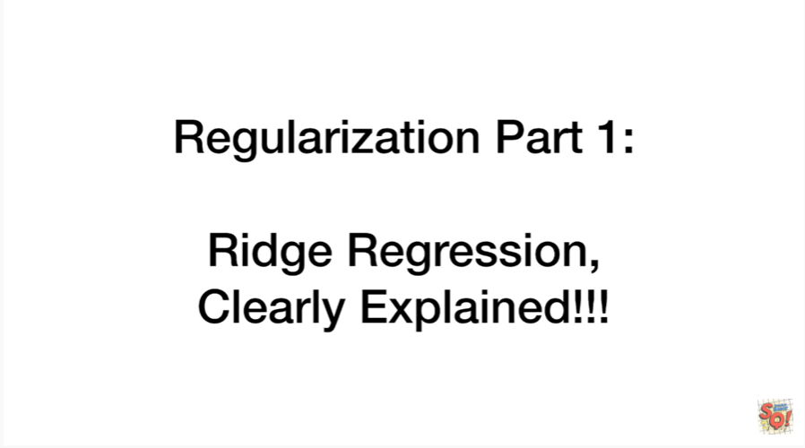

Today we're going to do part 1 of a series of video on regularization techniques.

In this video we're gonna cover Ridge regression and it's going to be clearly explained.

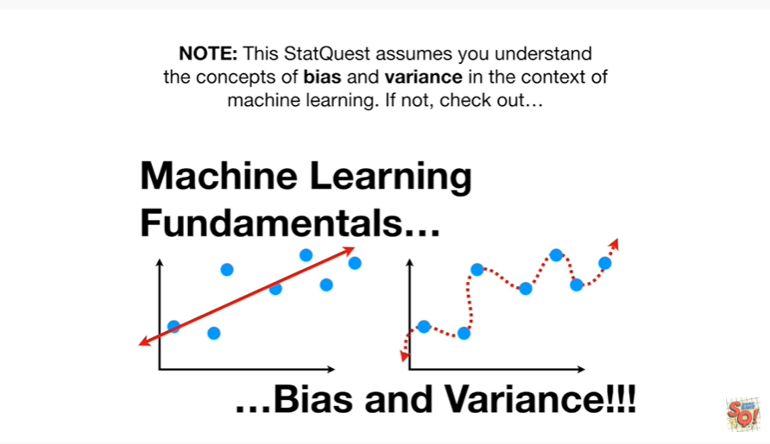

Note this stat quest assumes you understand the concepts of bias and variance in the context of machine learning.

If not check out machine learning fundamentals bias and variance.

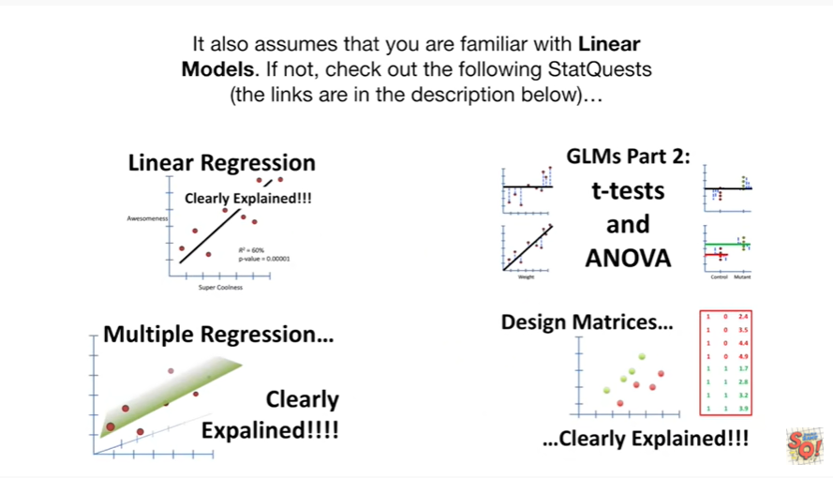

It also assumes that you are familiar with linear models if not check out the following stat quests the links are in the description below.

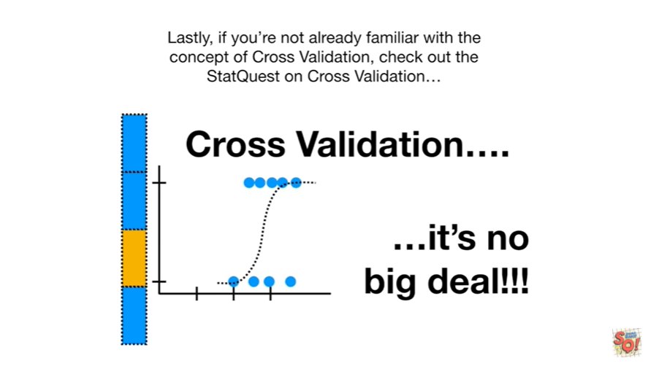

Lastly if you're not already familiar with the concept of cross-validation check out the stack west on cross-validation.



In this stack quest we will :

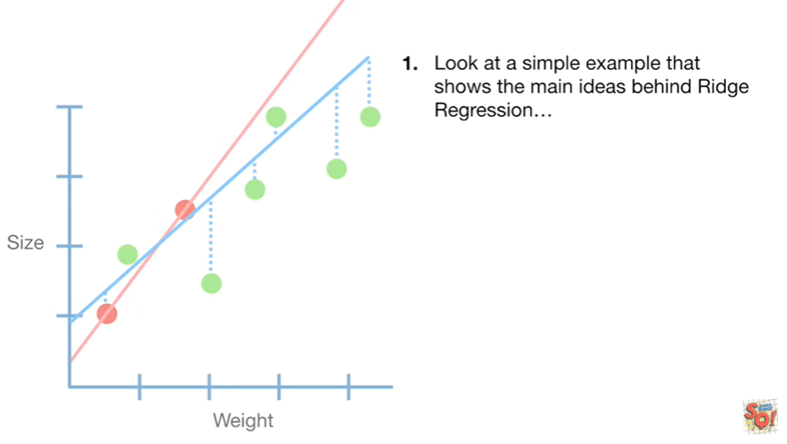

1. look at a simple example that shows the main ideas behind Ridge regression

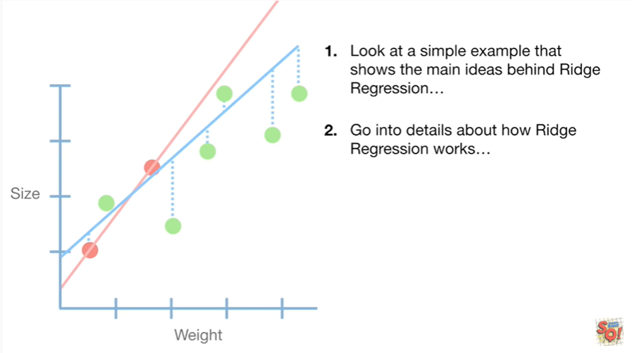

2. go into details about how Ridge regression works

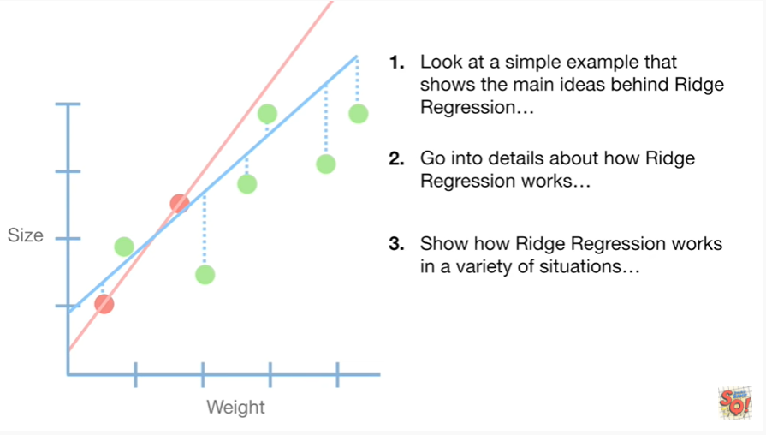

3. show how Ridge regression works in a variety of situations

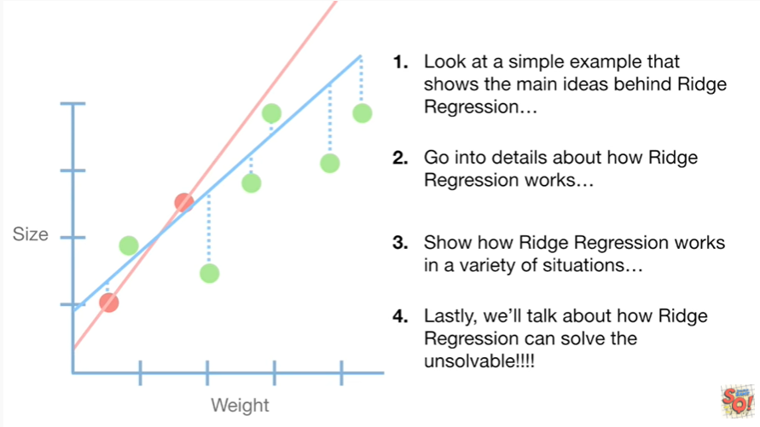

and 4. lastly we'll talk about how Ridge regression can solve the unsolvable.

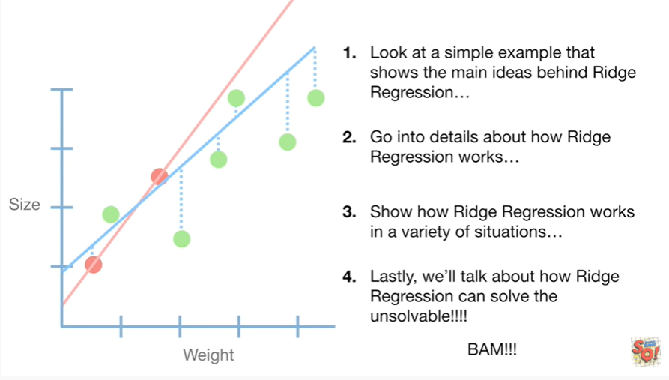

BAM !!!

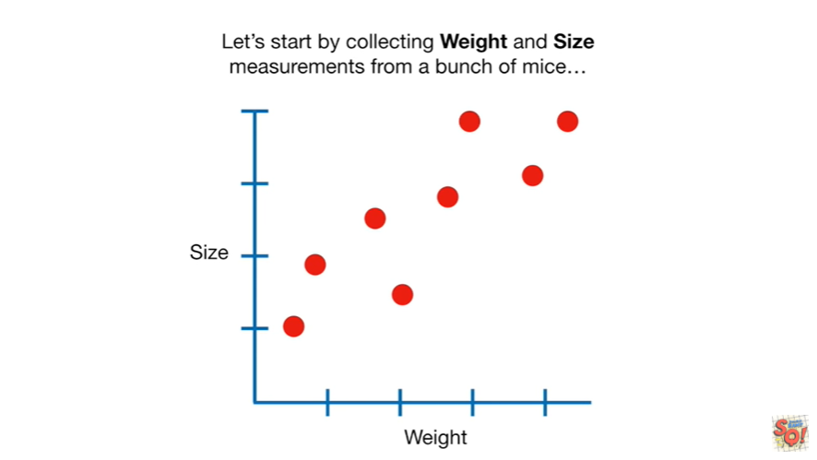

Let's start by collecting weight and size measurements from a bunch of mice

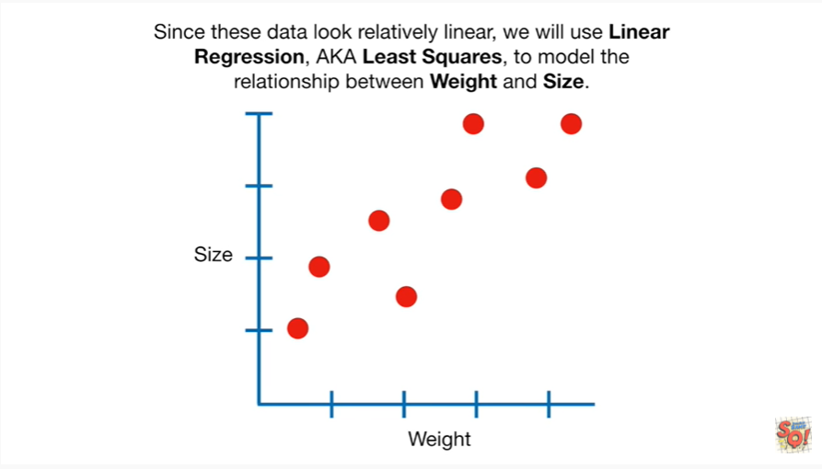

since these data look relatively linear we will use linear regression aka least squares to model the relationship between weight and size.

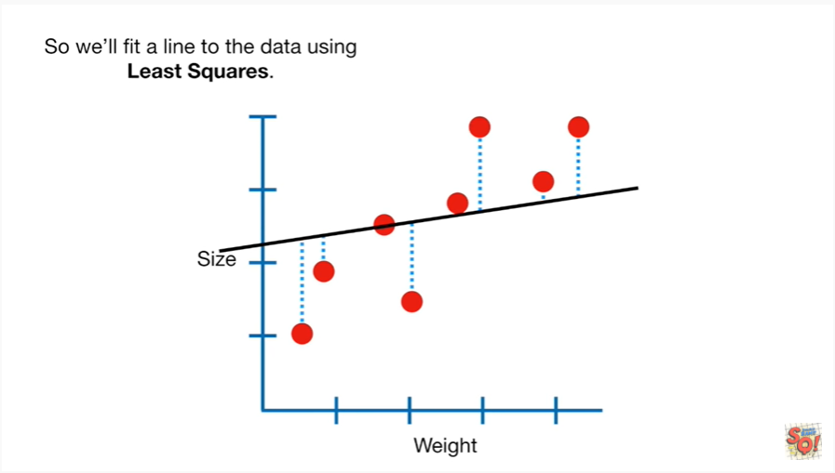

So we'll fit a line to the data using least squares.

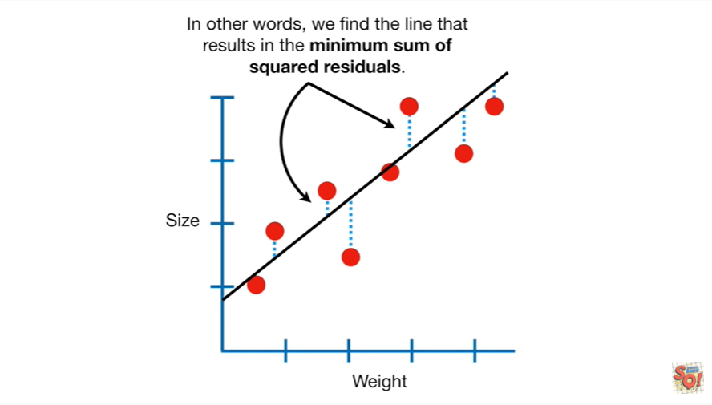

In other words we find the line that results in the minimum sum of squared residuals.

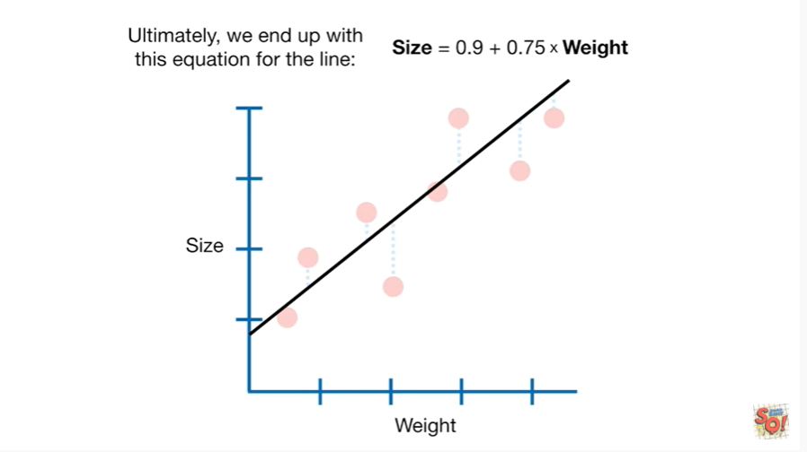

Ultimately we end up with this equation for the line.

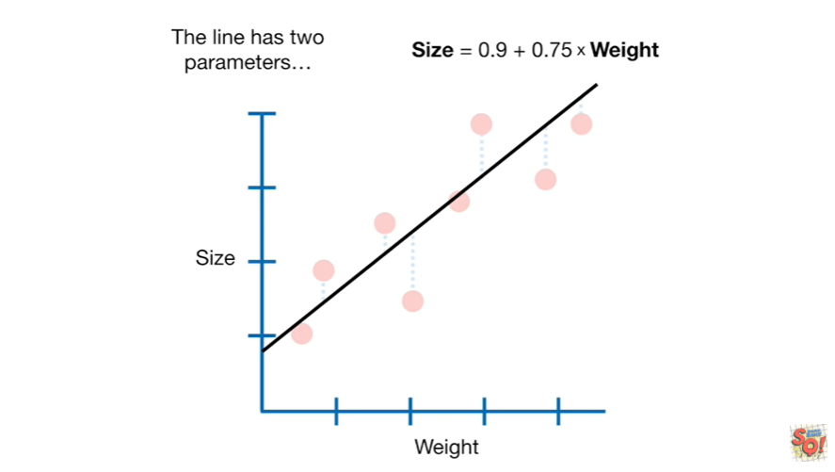

The line has two parameters

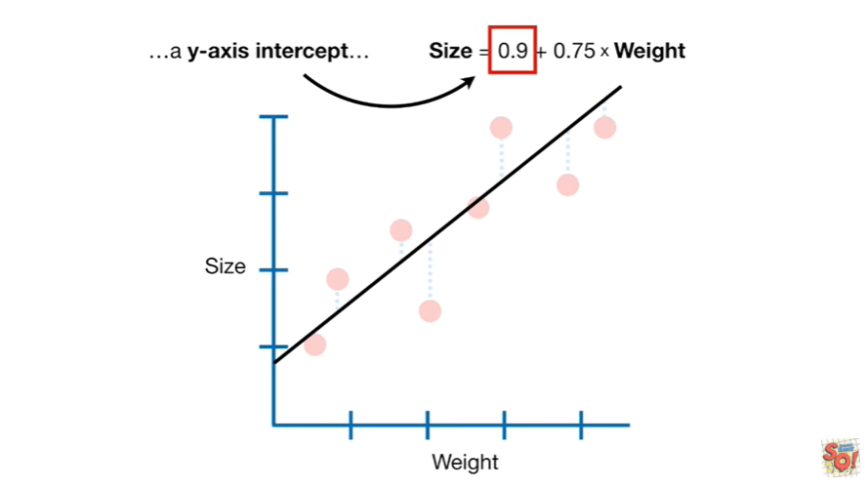

a y-axis intercept

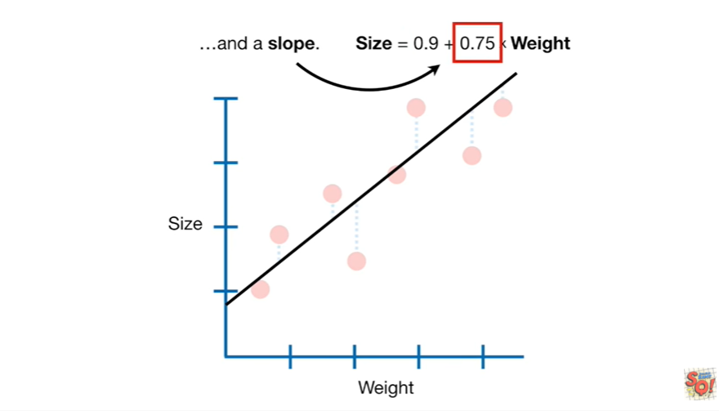

and a slope.

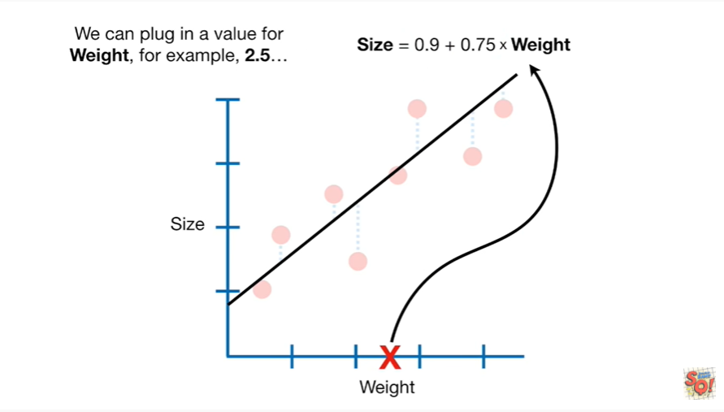

We can plug in a value for weight, for example two point five

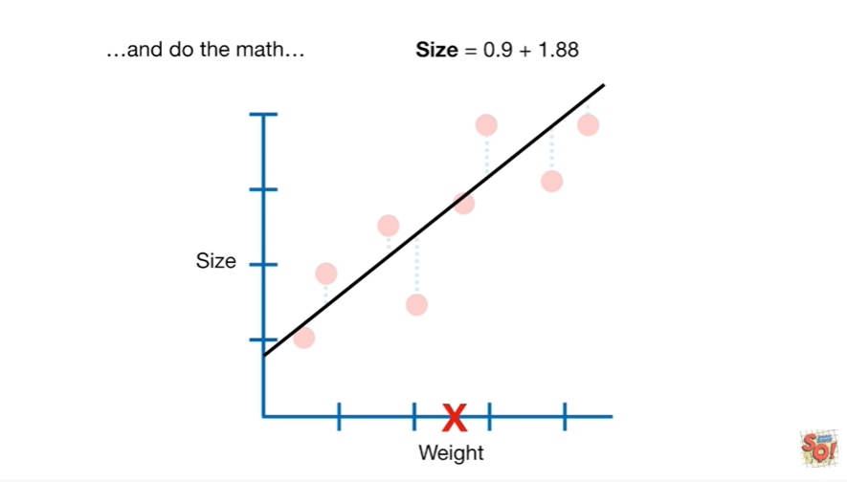

and do the math

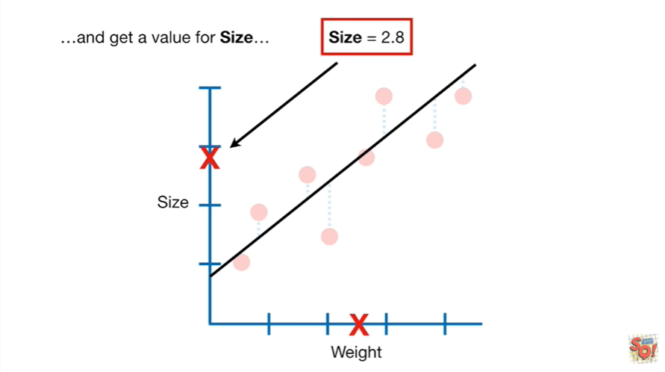

and get a value for size.

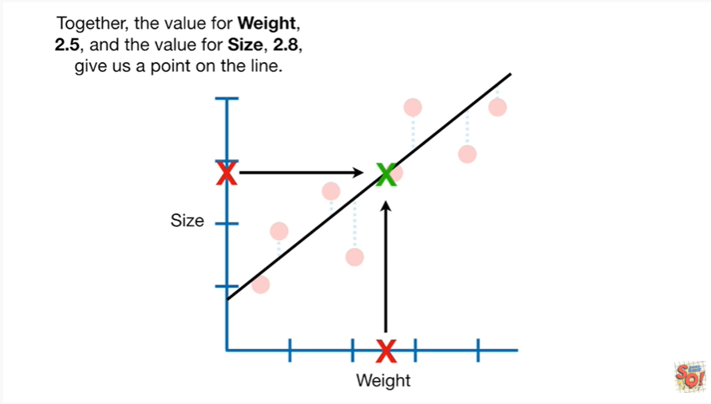

Together the value for weight two point five and the value for size two point eight give us a point on the line.

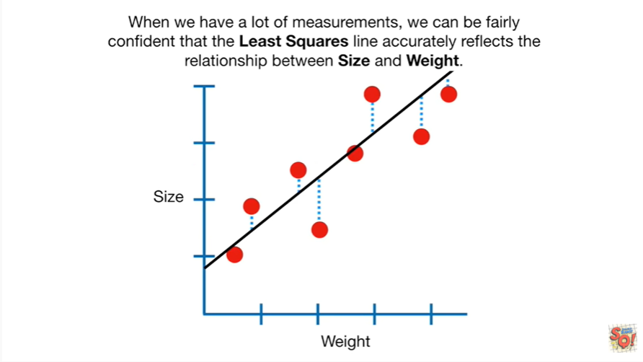

When we have a lot of measurements we can be fairly confident that the least squares line accurately reflects the relationship between size and weight.

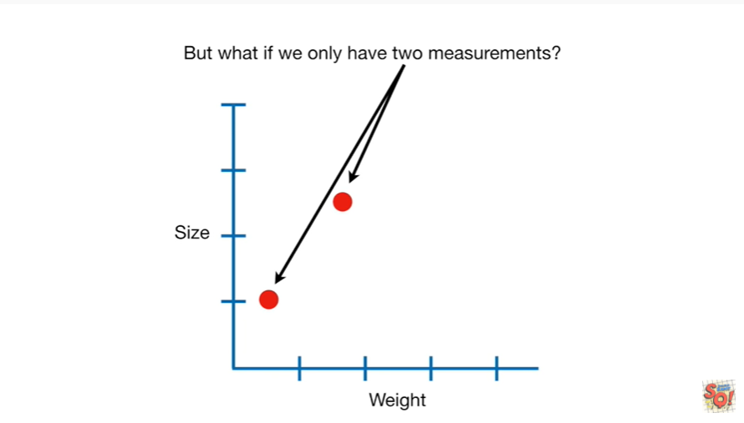

But what if we only have two measurements ?

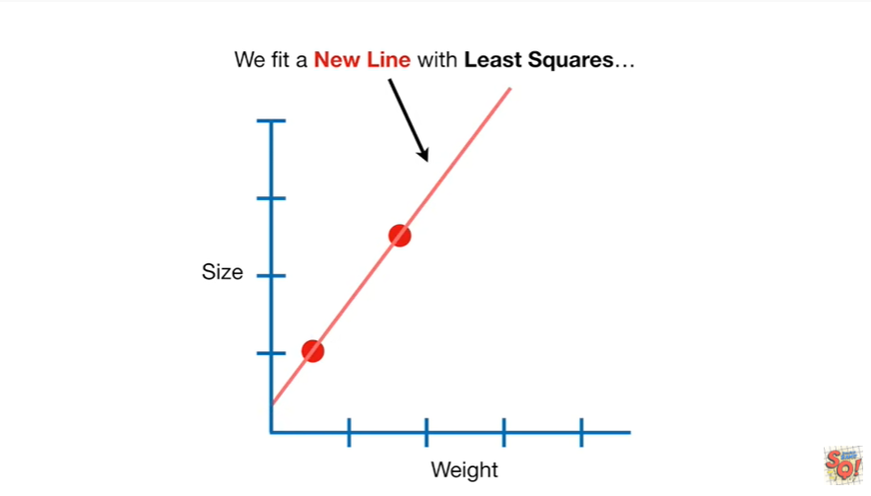

We fit a new line with least squares.

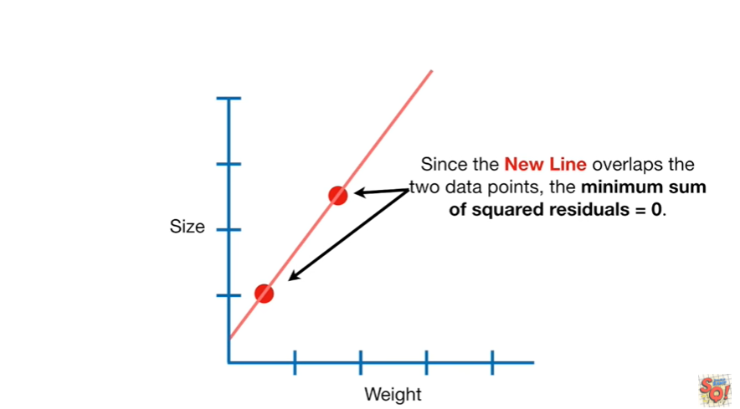

Since the new line overlaps the two data points, the minimum sum of squared residuals equals zero.

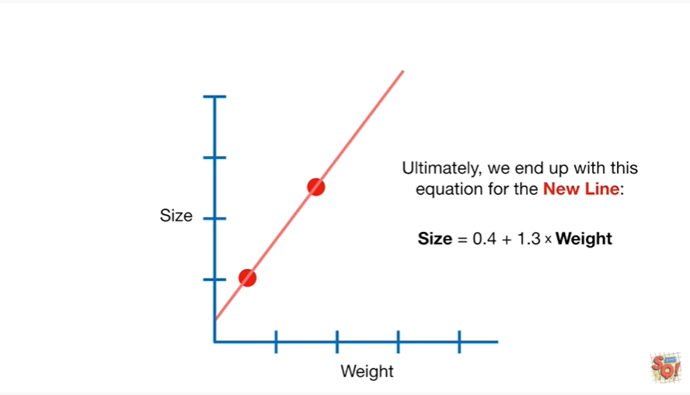

Ultimately we end up with this equation for the new line.

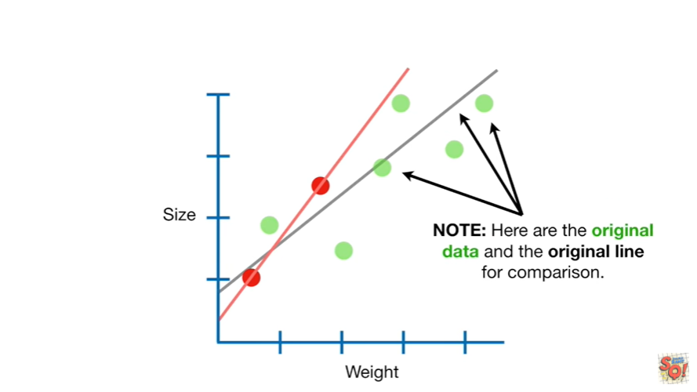

Note : here are the original data in the original line for comparison.

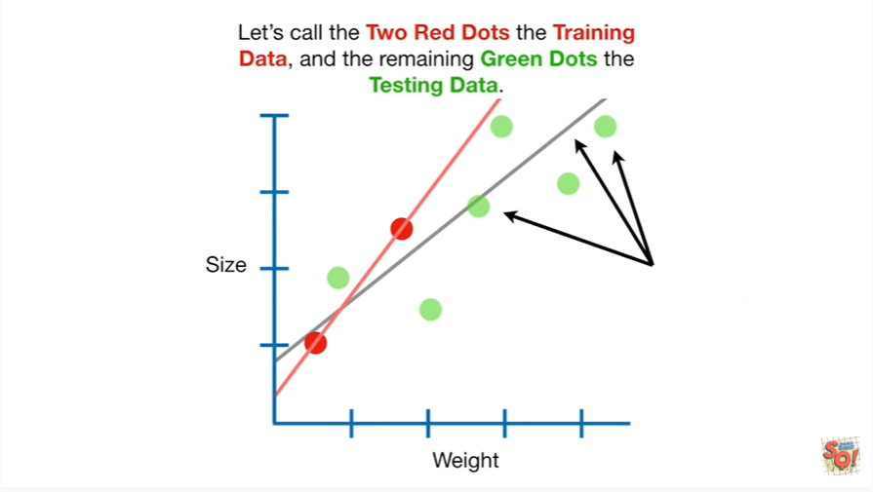

Let's call the two red dots the training data in the remaining green dots that testing data.

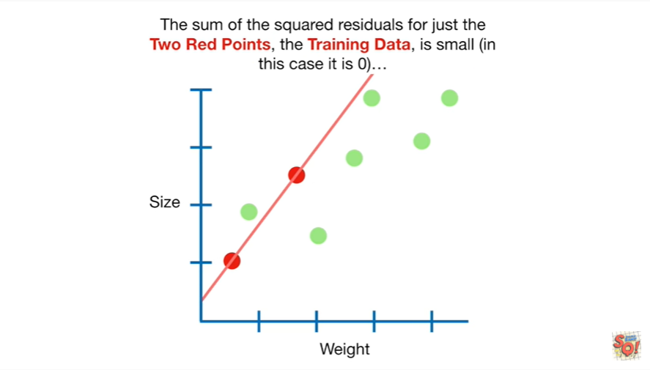

The sum of the squared residuals for just the two red points the training data is small in this case it is zero

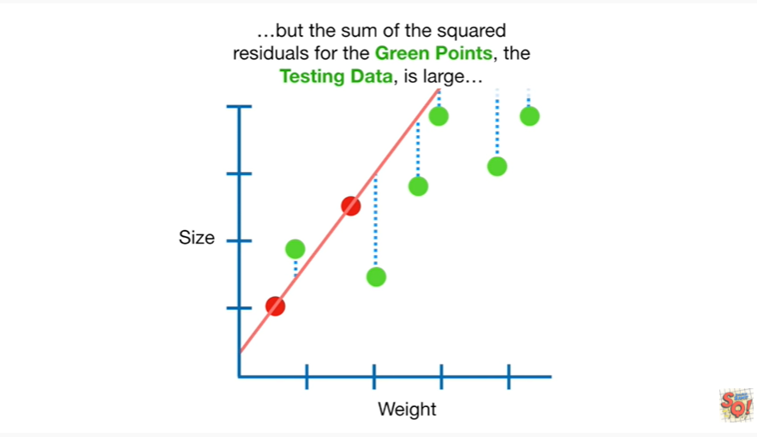

but the sum of the squared residuals for the green points the testing data is large

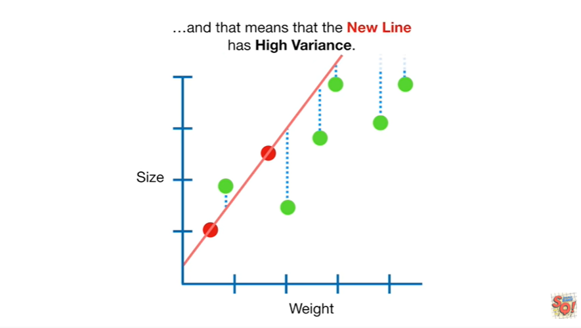

and that means that the new line has high variance.

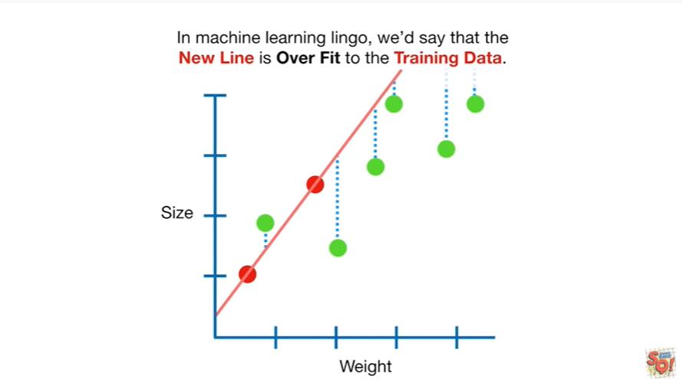

In machine learning lingo we'd say that the new line is over fit to the training data.

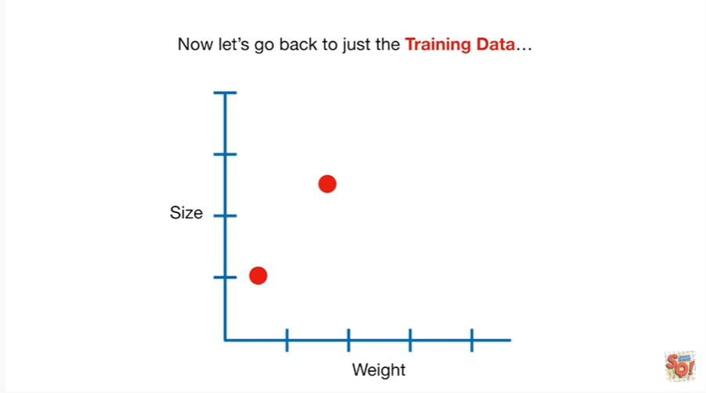

Now let's go back to just the training data.

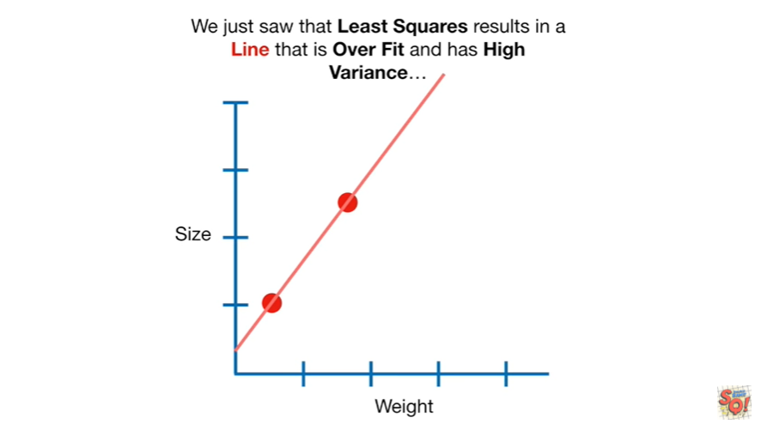

We just saw that least squares results in a line that is over fit and has high variance

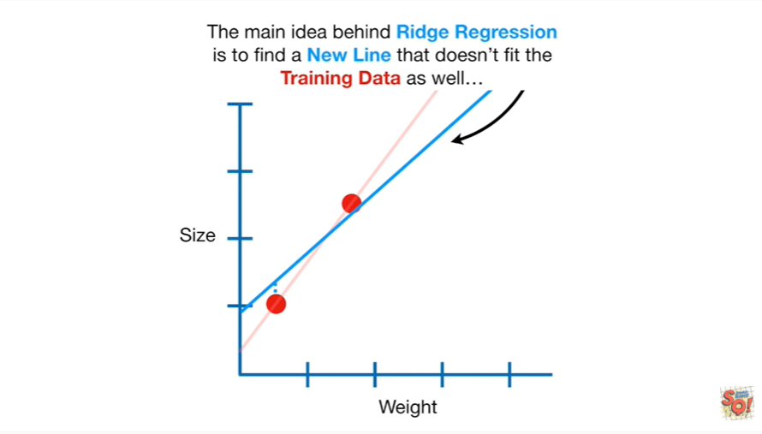

the main idea behind Ridge regression is to find a new line that doesn't fit the training data as well

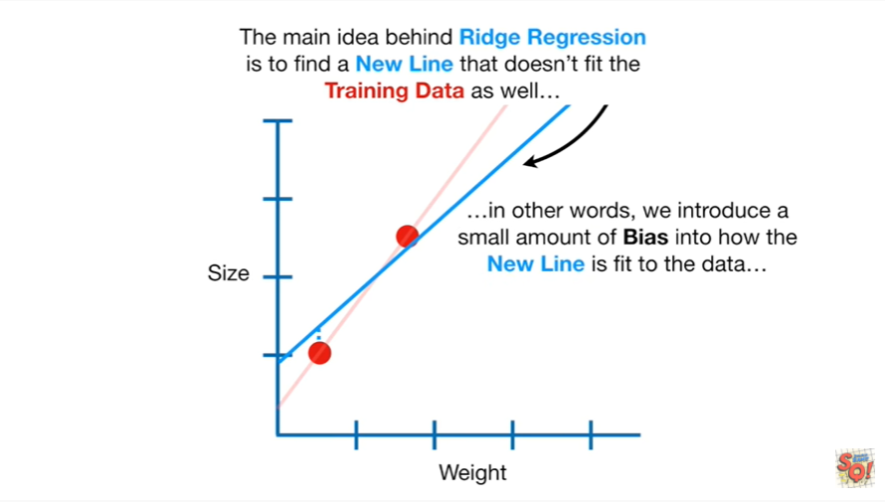

in other words we introduce a small amount of bias into how the new line is fit to the data

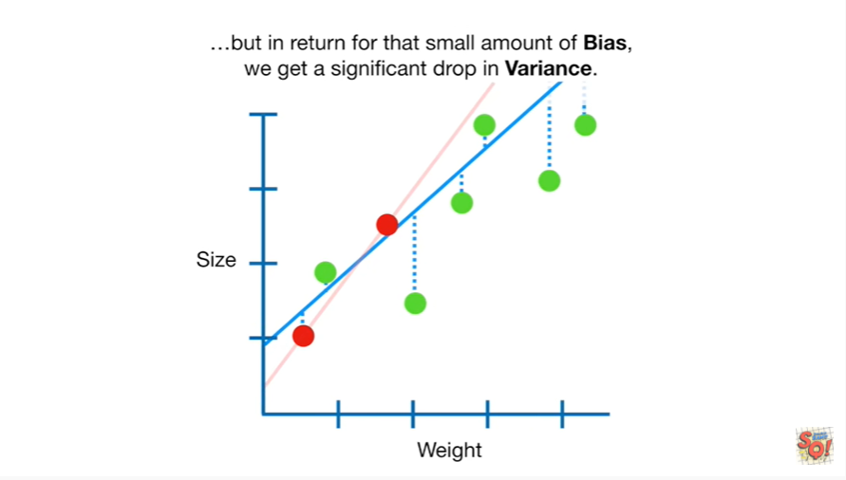

but in return for that small amount of bias we get a significant drop in variance.

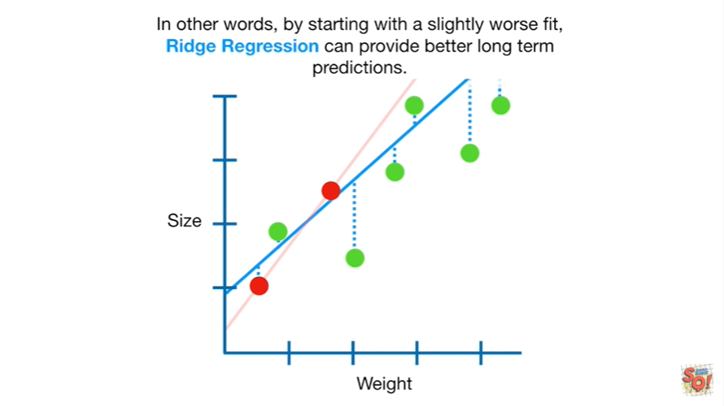

In other words by starting with a slightly worse fit Ridge regression can provide better long-term predictions.

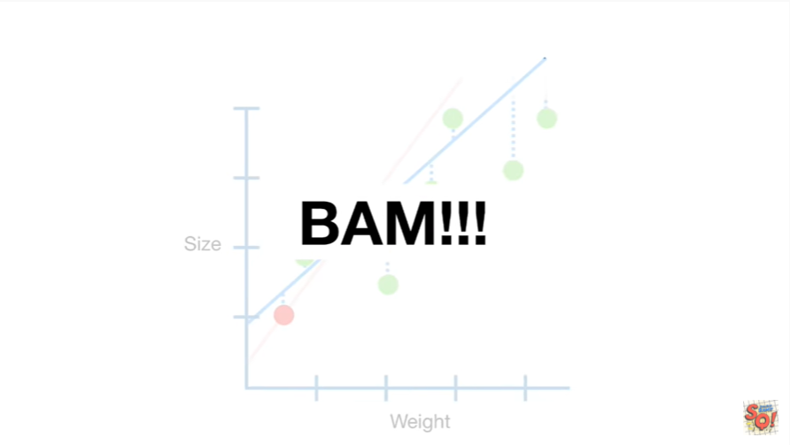

BAM !!!

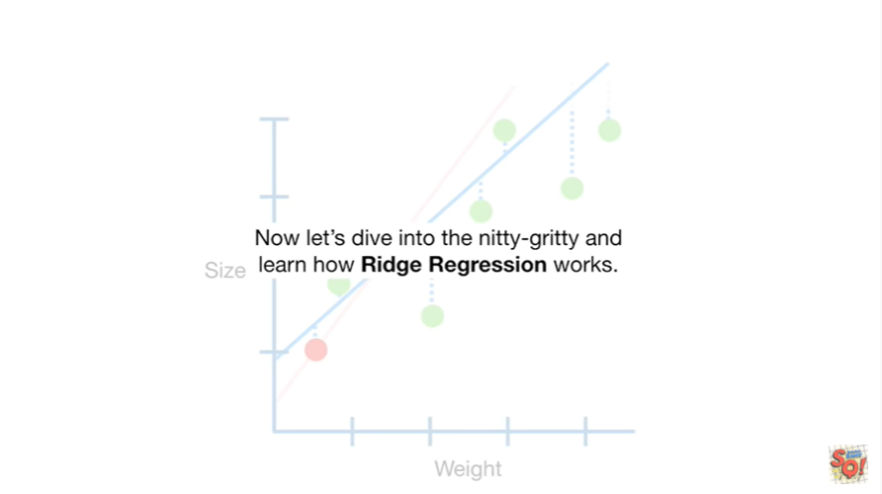

Now let's dive into the nitty-gritty and learn how Ridge regression works.

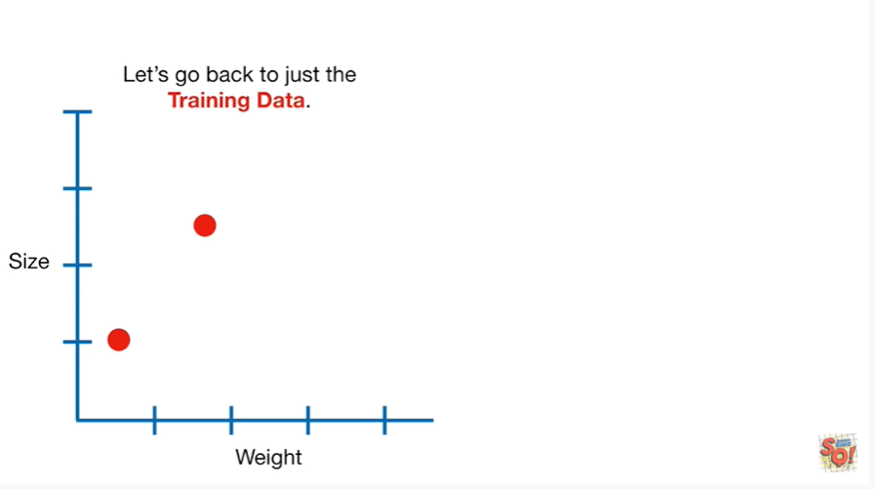

Let's go back to just the training data.

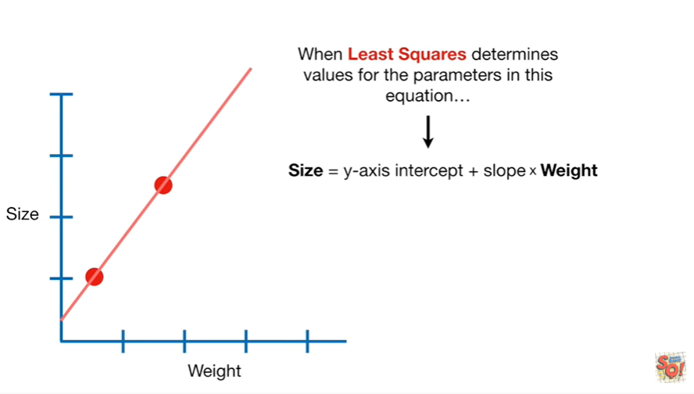

When least-squares determines values for the parameters in this equation

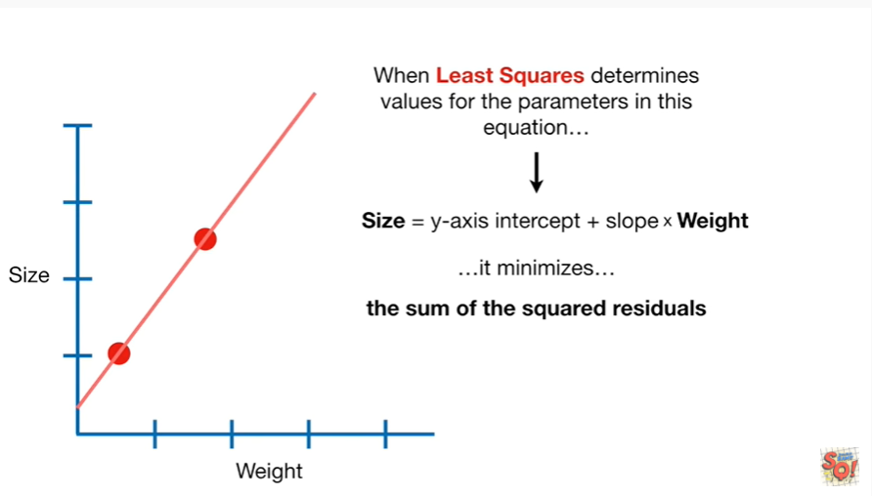

it minimizes the sum of the squared residuals.

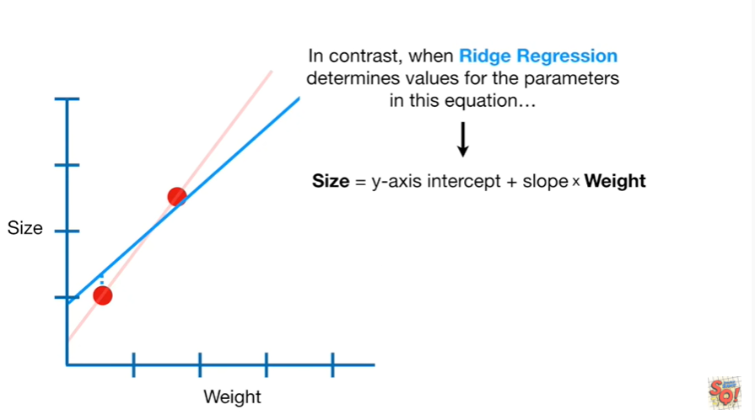

In contrast when Ridge regression determines the values for the parameters in this equation

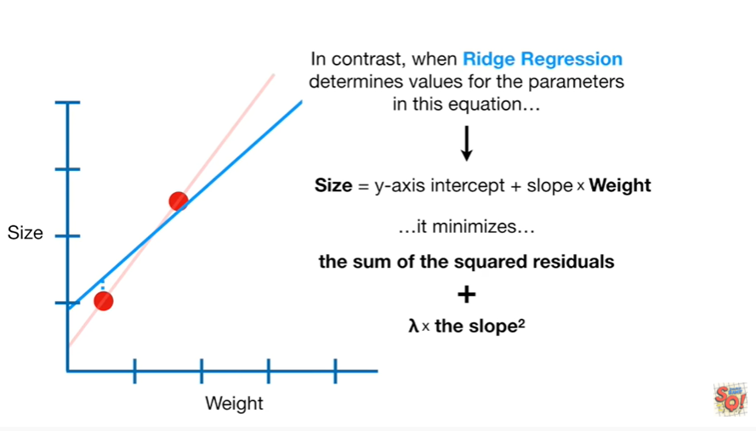

it minimizes the sum of the squared residuals plus lambda times the slope squared.

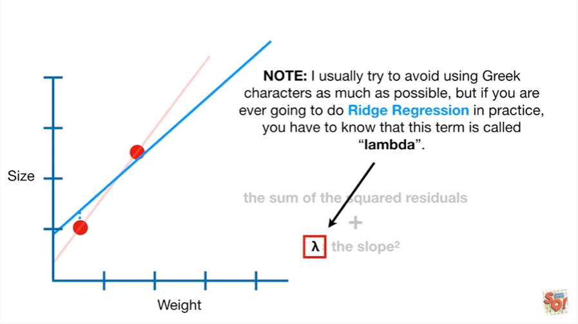

Note : I usually try to avoid using Greek characters as much as possible but if you are ever going to do Ridge regression in practice you have to know that this term is called lambda.

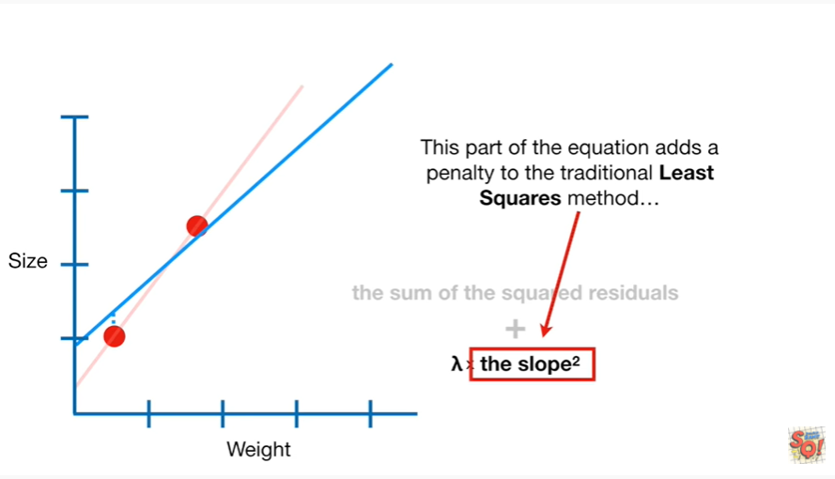

This part of the equation adds a penalty to the traditional least squares method

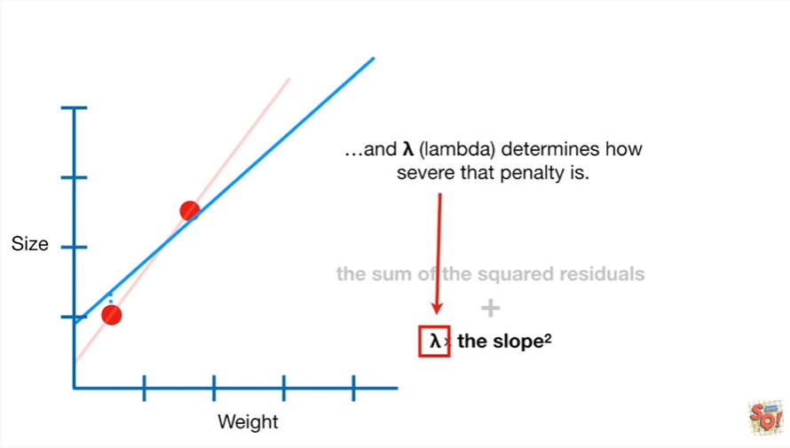

and lambda determines how severe that penalty is.

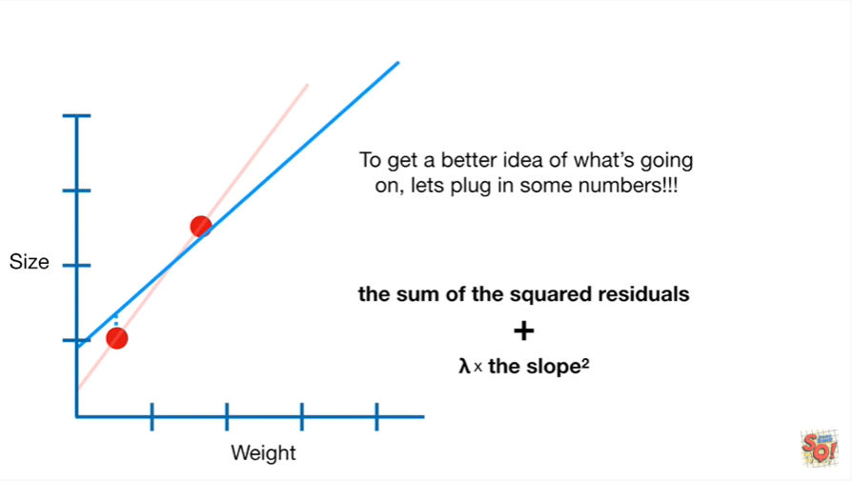

To get a better idea of what's going on let's plug in some numbers.

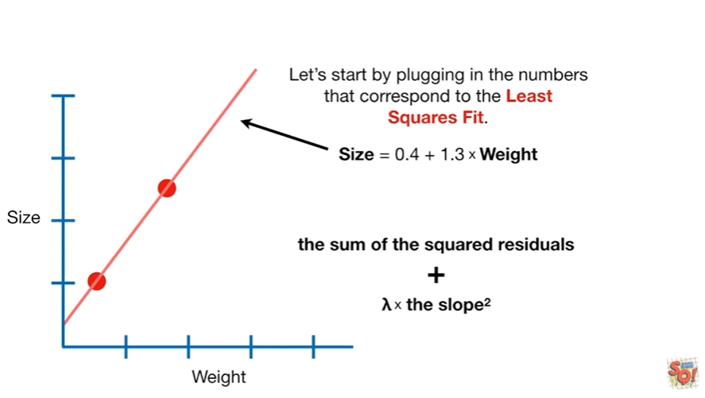

Let's start by plugging in the numbers that correspond to the least squares fit.

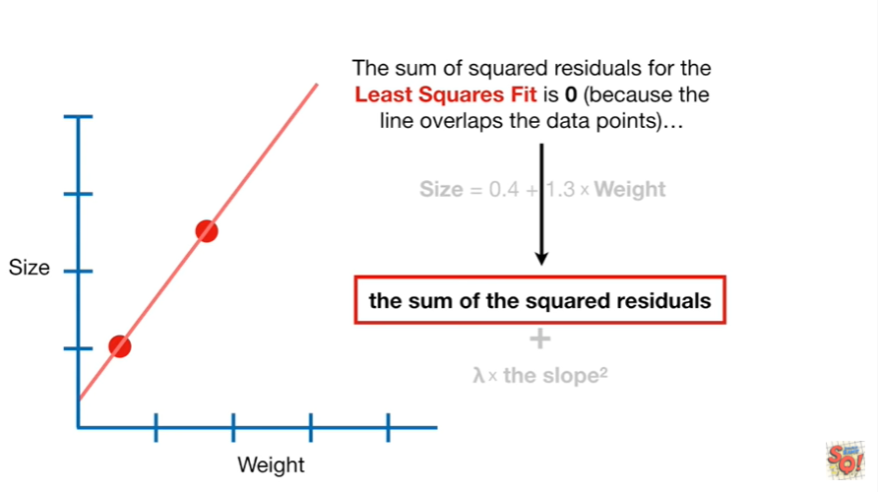

The sum of the squared residuals for the least squares fit

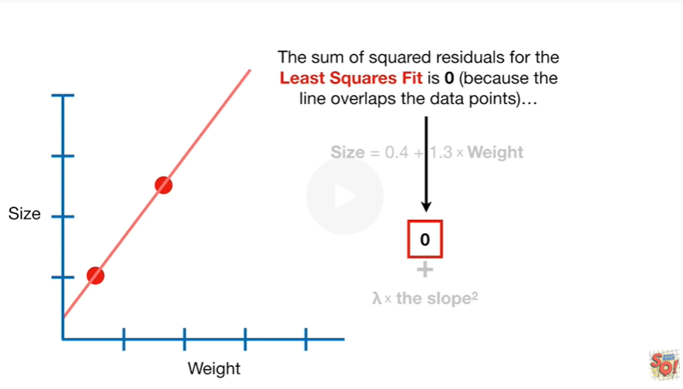

is zero because the line overlaps the data points

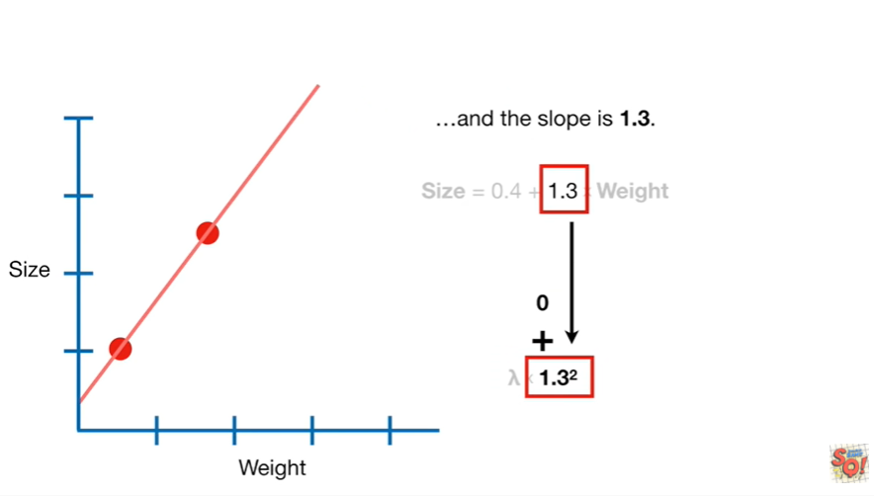

and the slope is one point three.

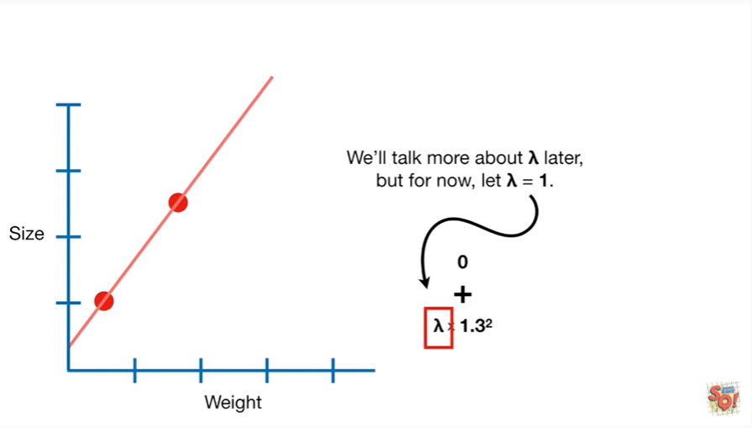

We'll talk more about lambda later but for now let lambda equal one.

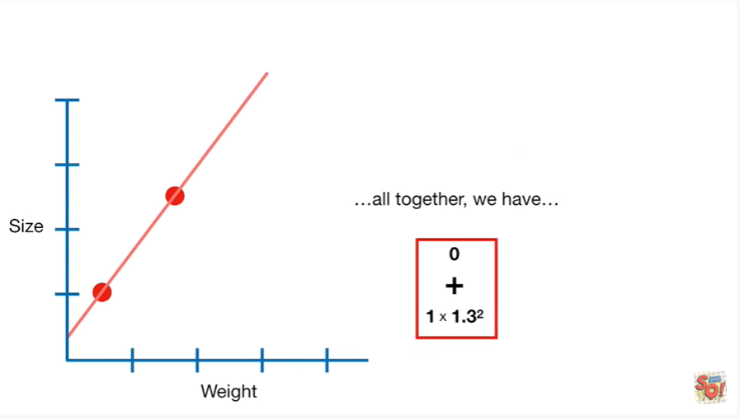

All together we have zero plus one times one point three squared

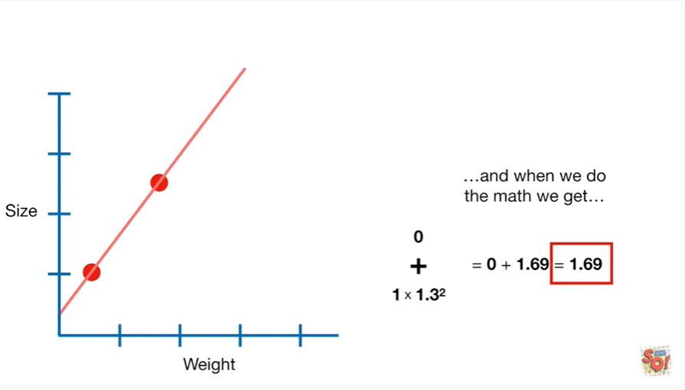

and when we do the math we get one point six nine.

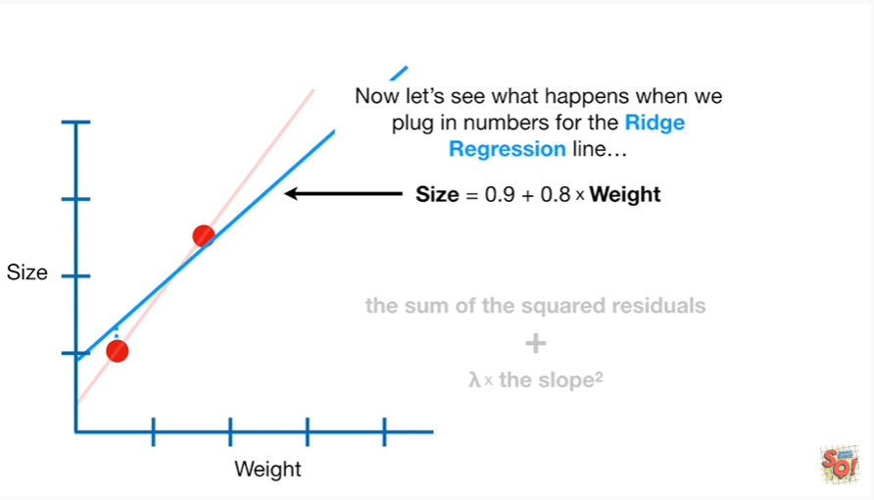

Now let's see what happens when we plug in numbers for the ridge regression line.

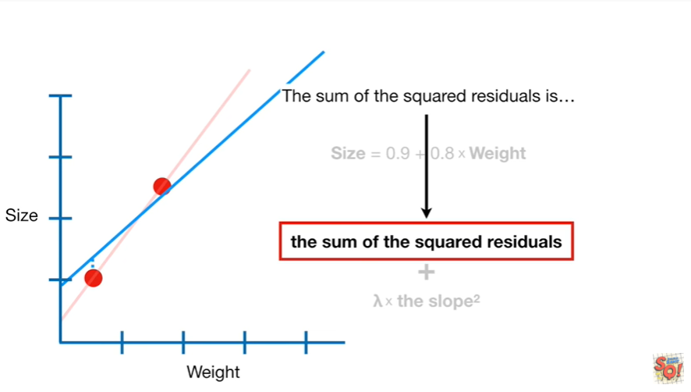

The sum of the squared residuals is

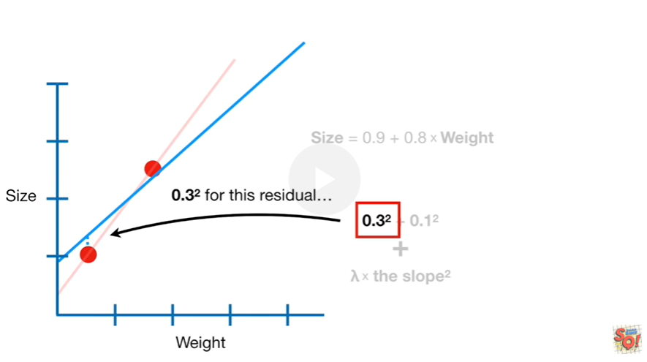

zero point three squared for this residual

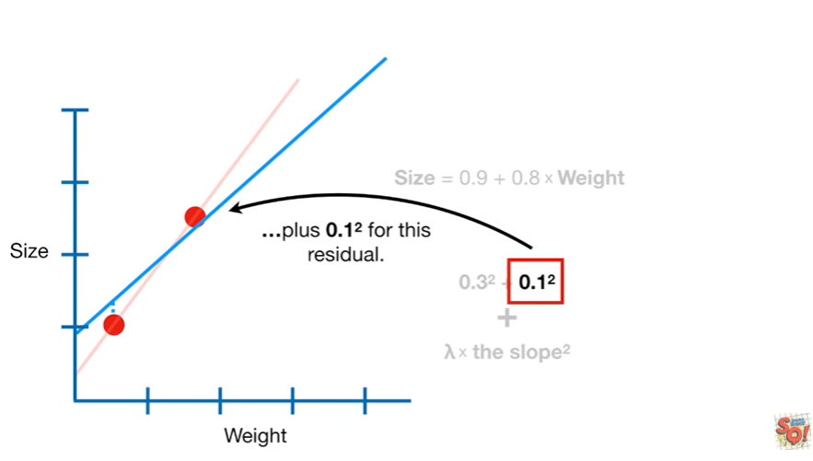

plus zero point one squared for this residual

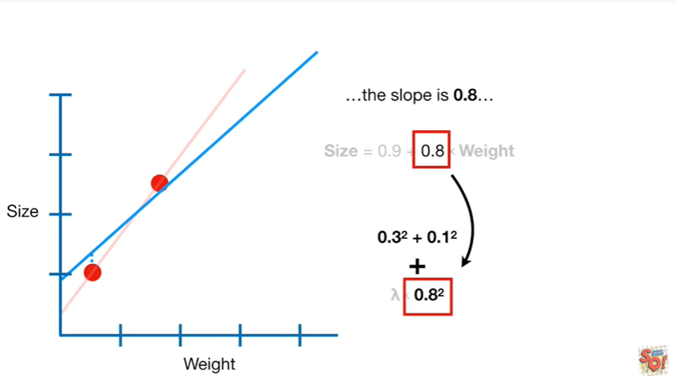

the slope is 0.8

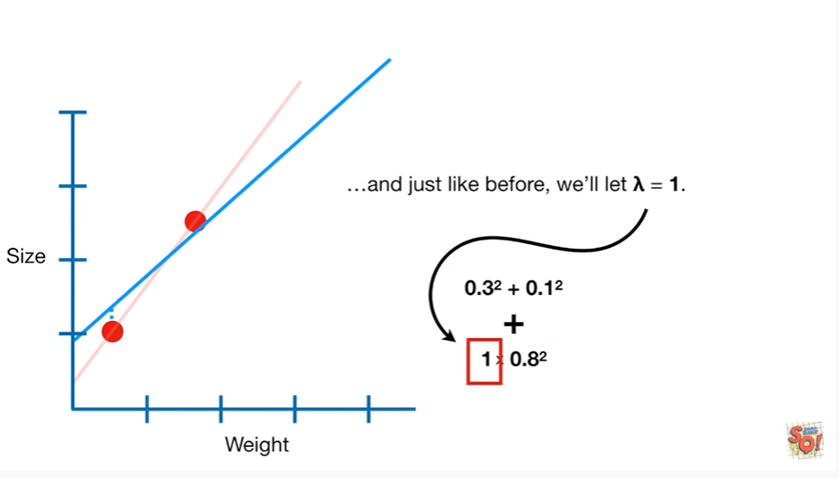

and just like before we'll let lambda equal 1.

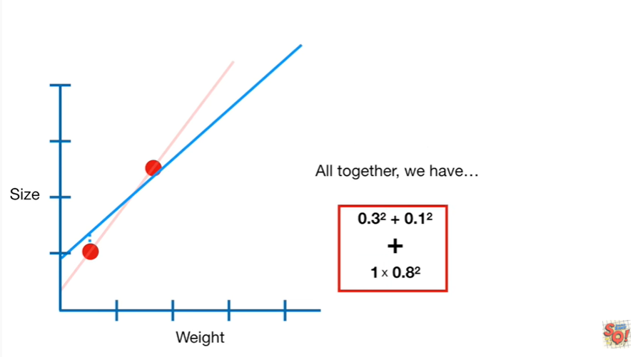

Altogether we have 0.3 squared plus 0.1 squared plus 1 times 0.8 squared

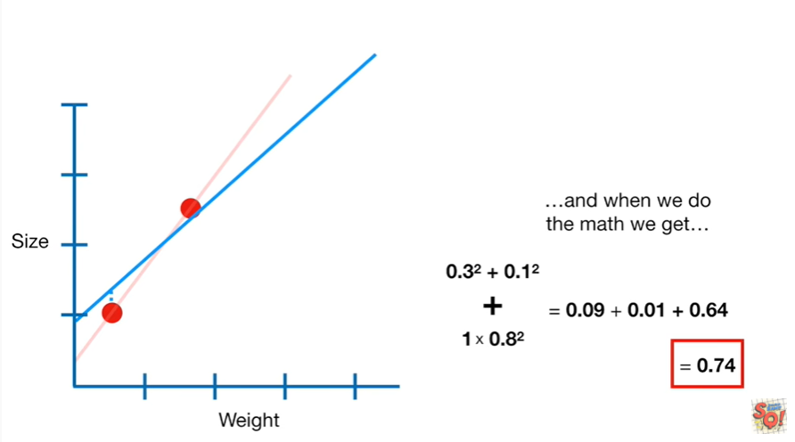

and when we do the math we get 0.74.

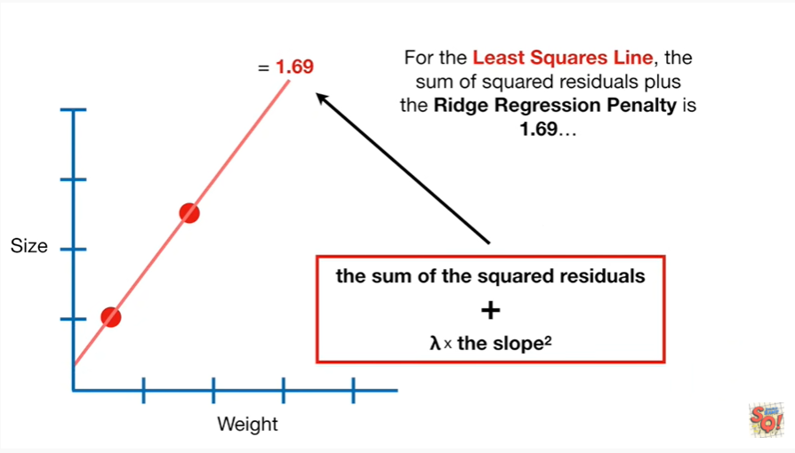

For the least squares line the sum of squared residuals plus the ridge regression penalty is one point six nine.

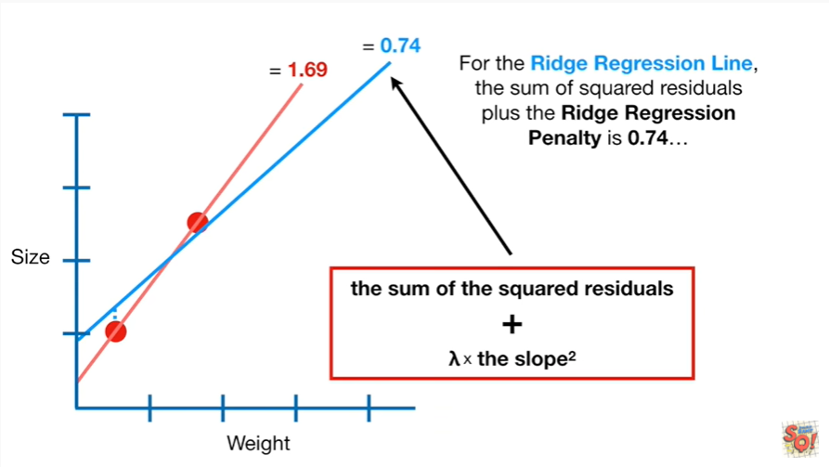

For the ridge regression line the sum of squared residuals plus the ridge regression penalty is 0.74.

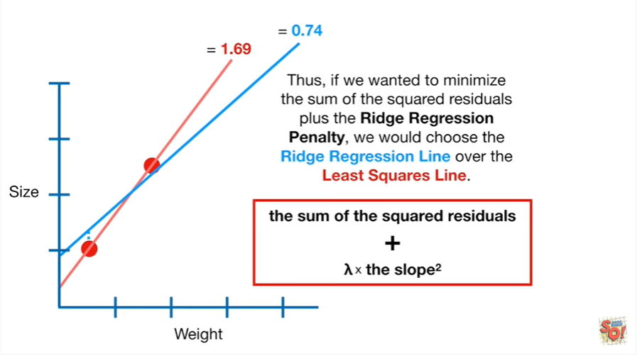

Thus if we wanted to minimize the sum of the squared residuals plus the ridge regression penalty we would choose the ridge regression line over the least squares line.

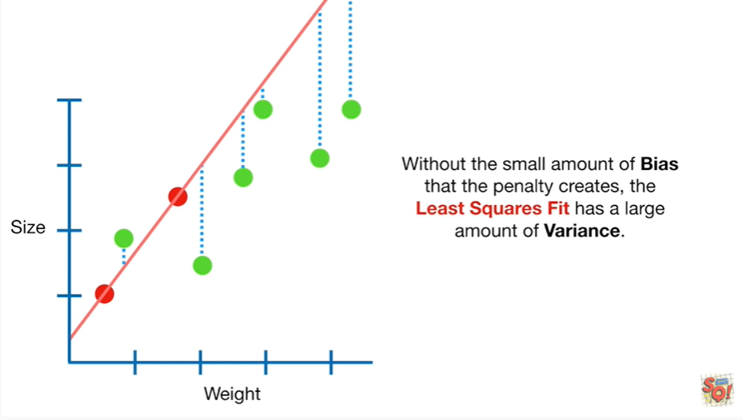

Without the small amount of bias that the penalty creates the least squares fit has a large amount of variance.

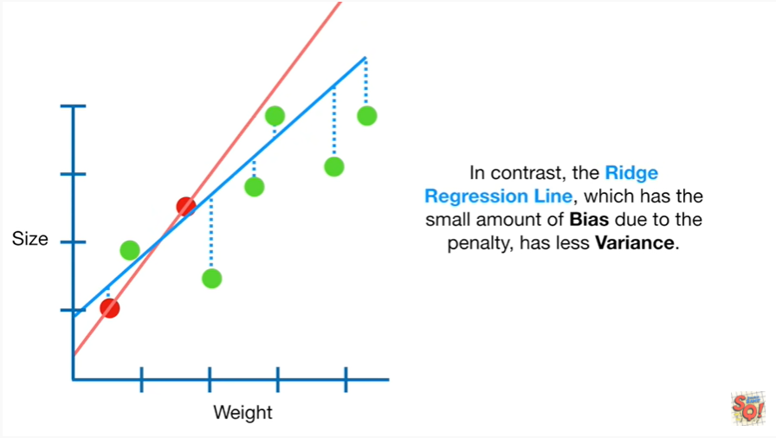

In contrast the ridge regression line which has a small amount of bias due to the penalty has less variance.

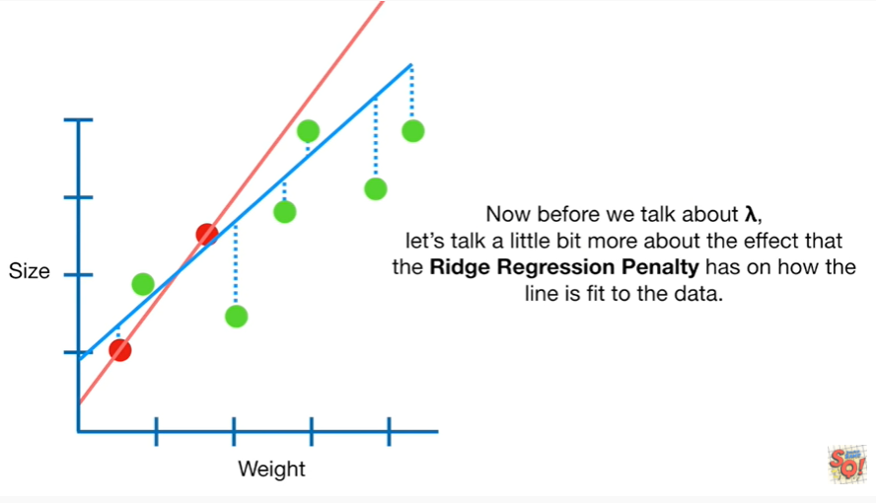

Now before we talk about lambda let's talk a little bit more about the effect that the ridge regression penalty has on how the line is fit to the data.

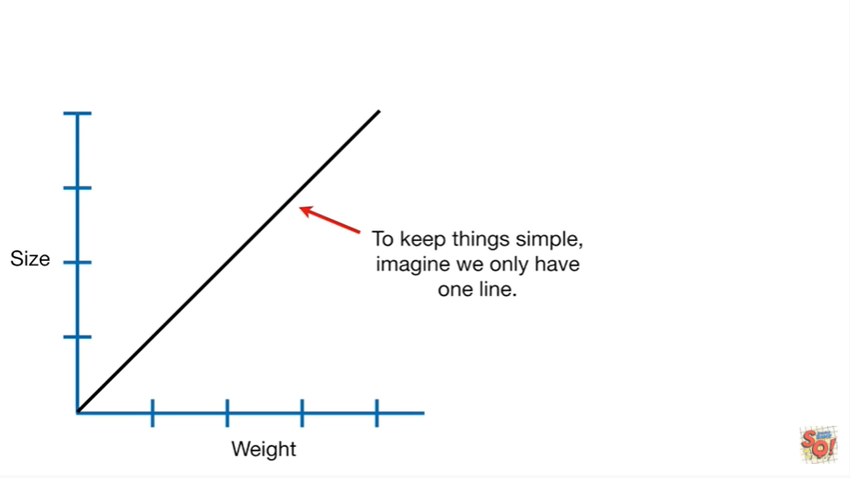

To keep things simple imagine we only have one line.

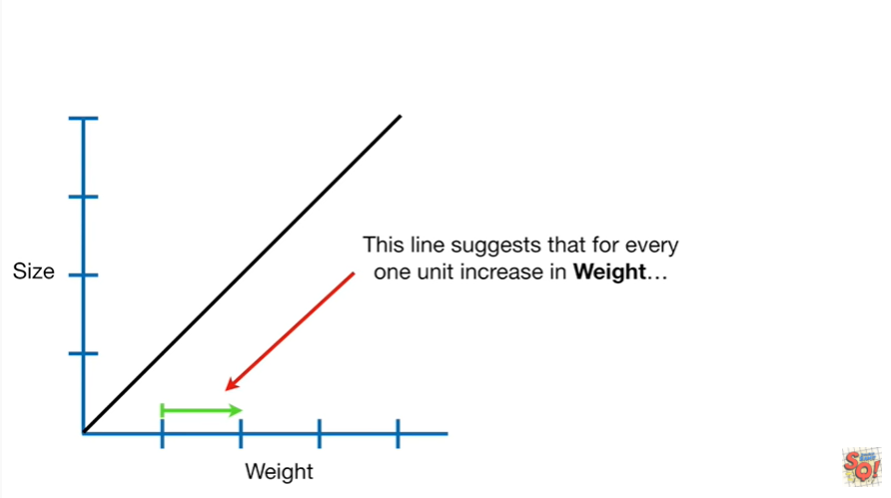

This line suggests that for every one unit increase in weight

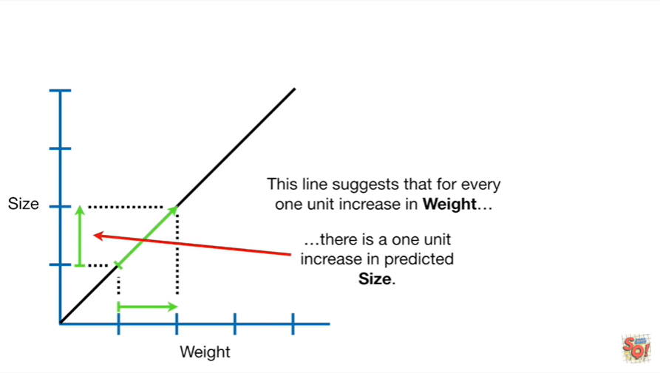

there is a one unit increase in predicted size.

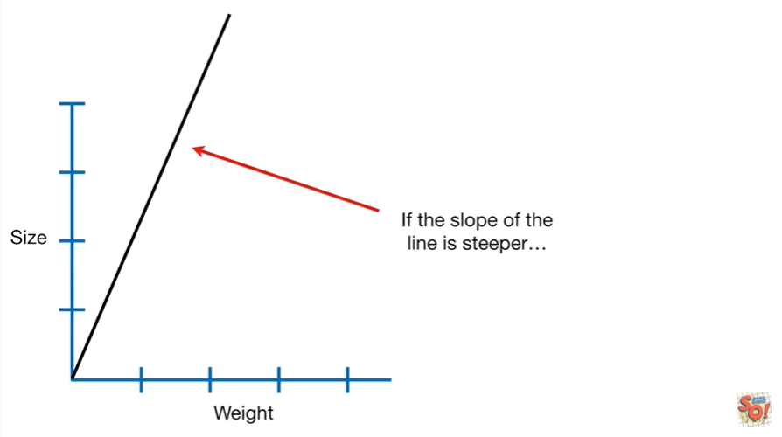

If the slope of the line is steeper

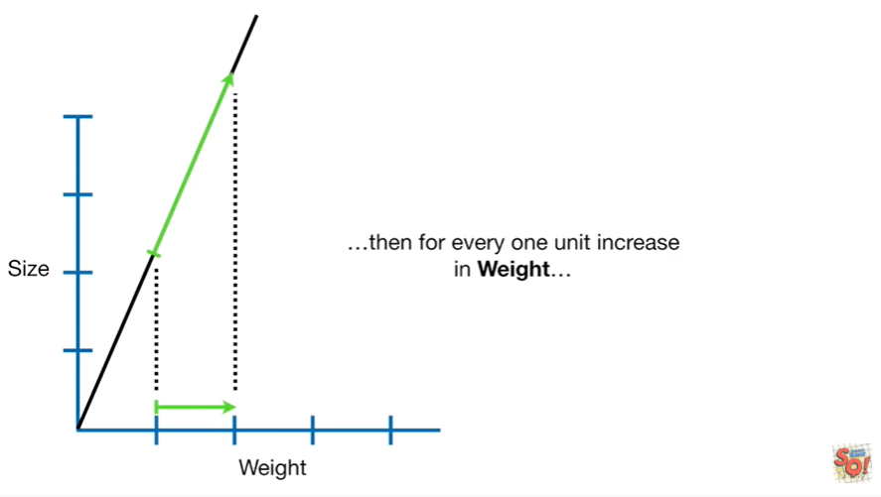

than for every one unit increase in weight

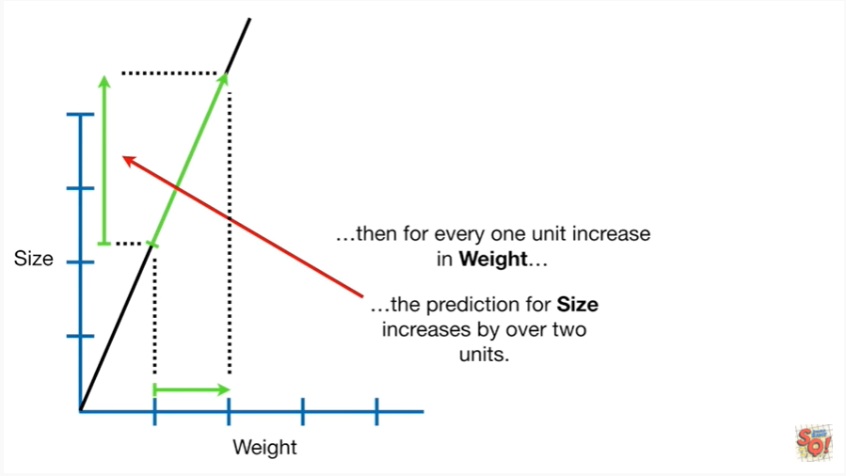

the prediction for size increases by over two units.

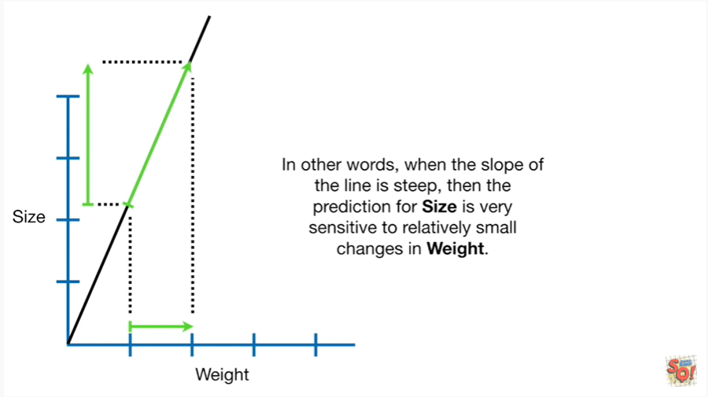

In other words when the slope of the line is steep then the prediction for size is very sensitive to relatively small changes in weight.

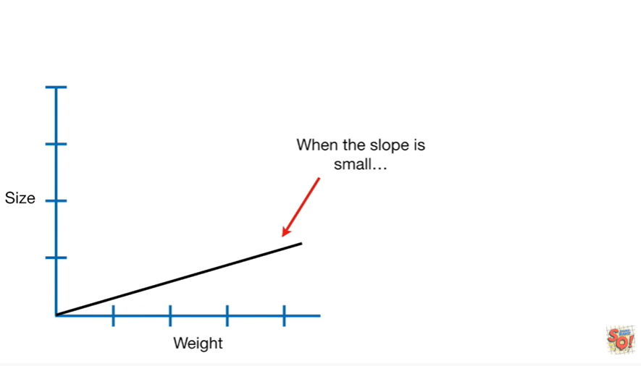

When the slope is small

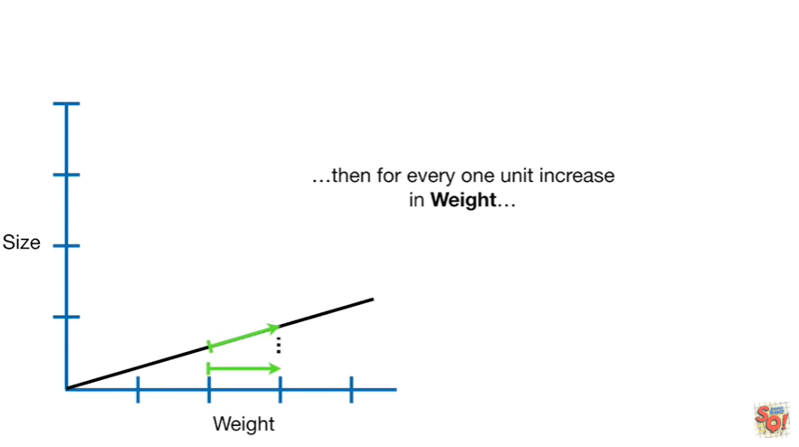

then for every one unit increase in weight

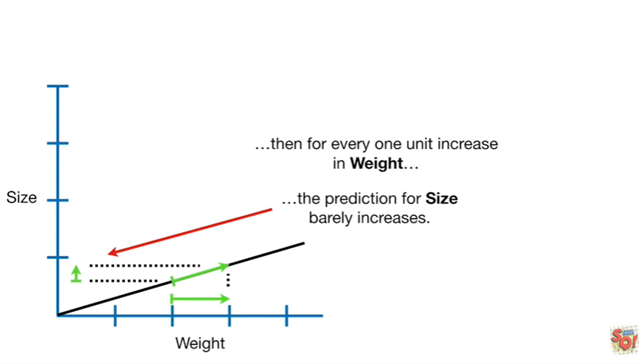

the prediction for size barely increases.

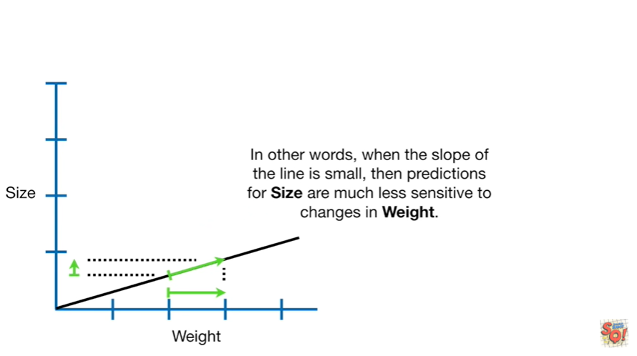

In other words when the slope of the line is small then predictions for size are much less sensitive to changes in weight.

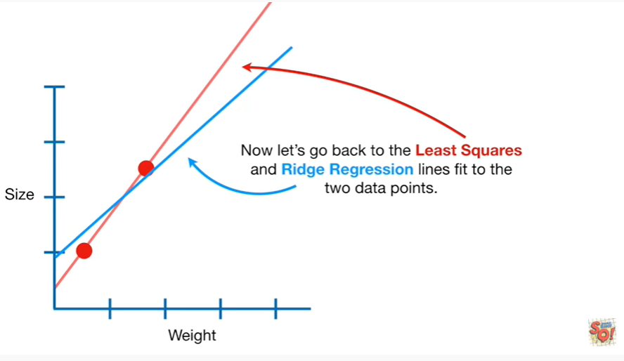

Now let's go back to the least squares and Ridge regression lines fit to the two data points.

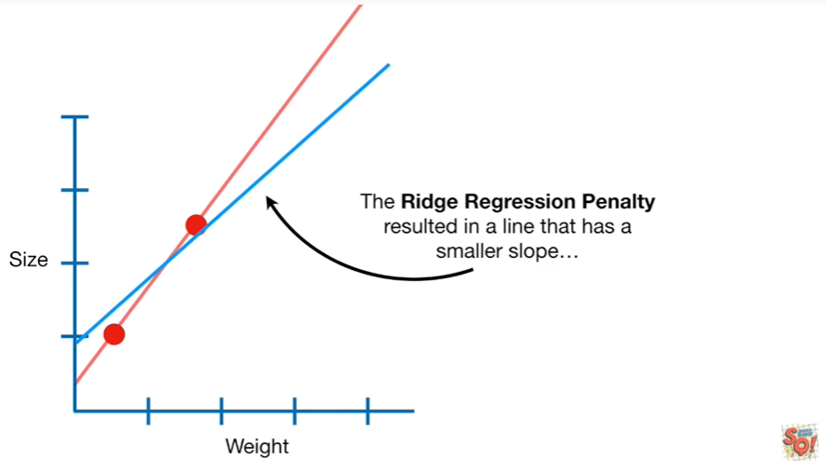

The ridge regression penalty resulted in a line that has a smaller slope

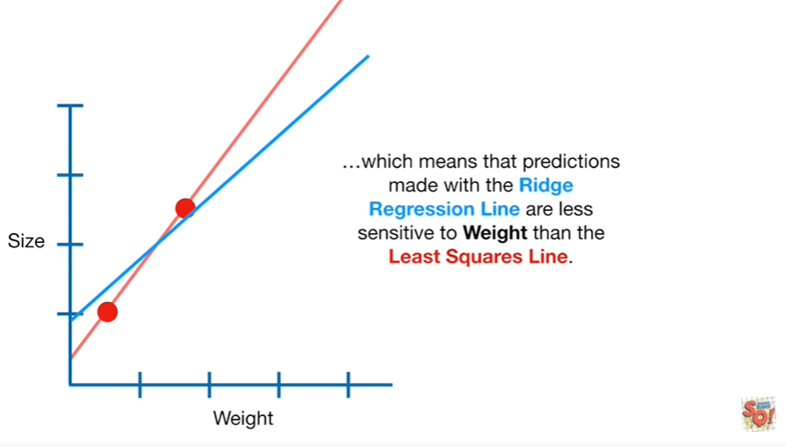

which means that predictions made with the ridge regression line are less sensitive to weight than the least squares line.

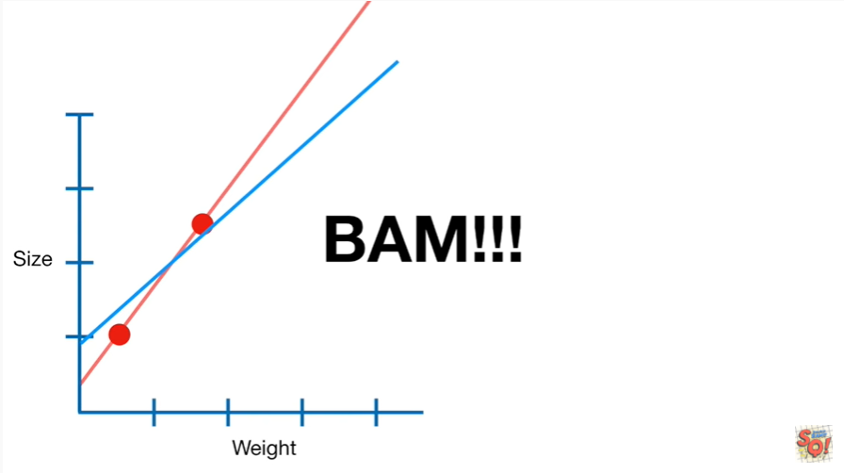

BAM !!!

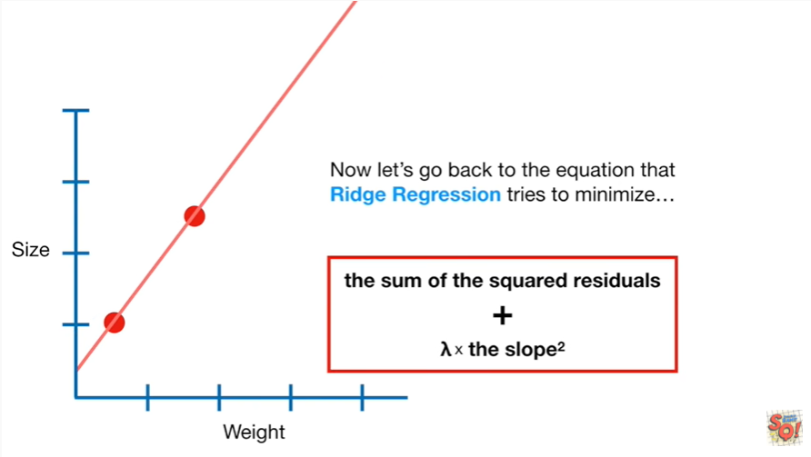

Now let's go back to the equation that Ridge regression tries to minimize

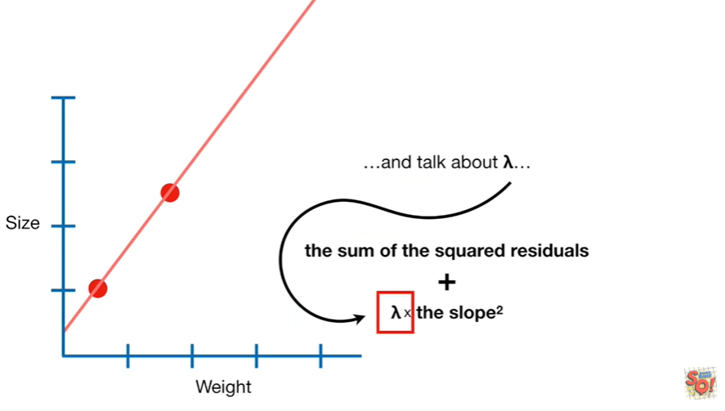

and talk about lambda.

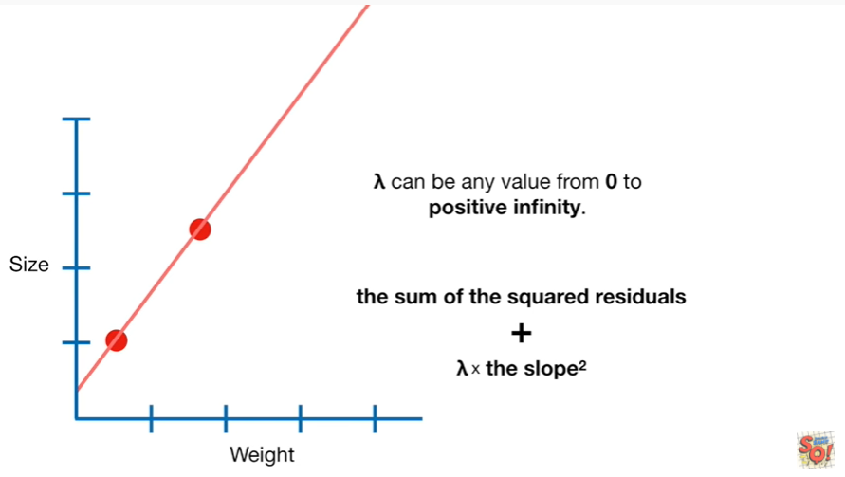

Lambda can be any value from 0 to positive infinity.

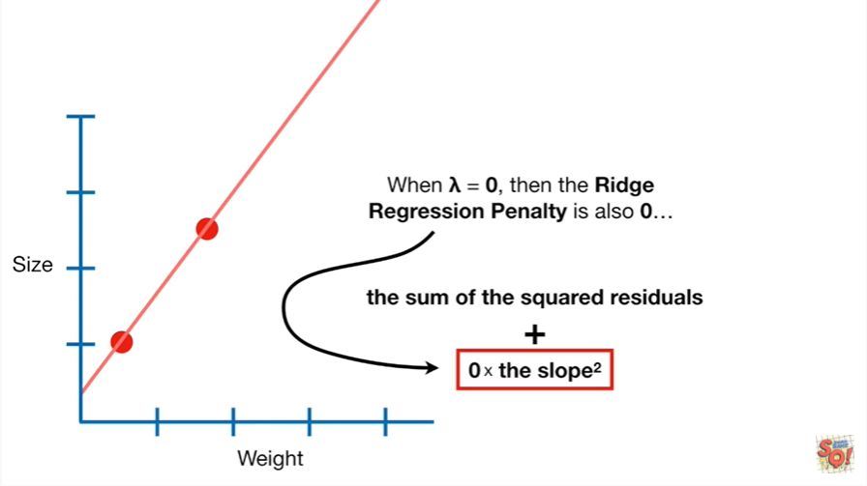

When lambda equals zero then the ridge regression penalty is also zero

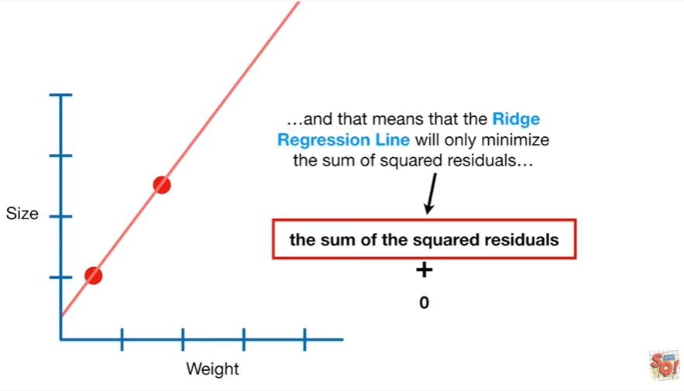

and that means that the ridge regression line will only minimize the sum of squared residuals

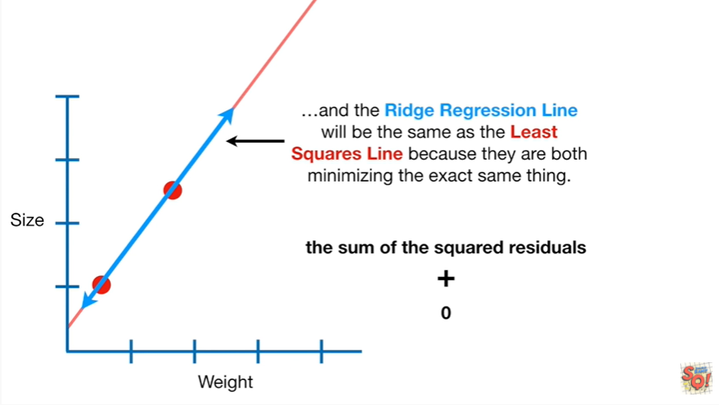

and the ridge regression line will be the same as the least squares line because they are both minimizing the exact same thing.

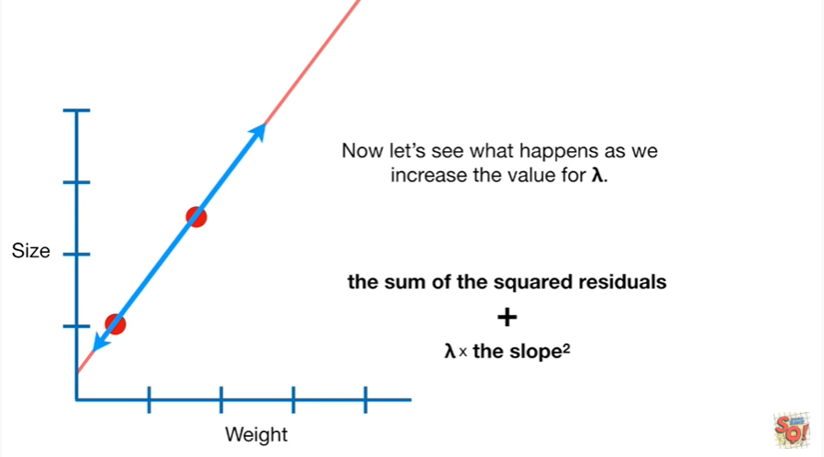

Now let's see what happens as we increase the value for lambda.

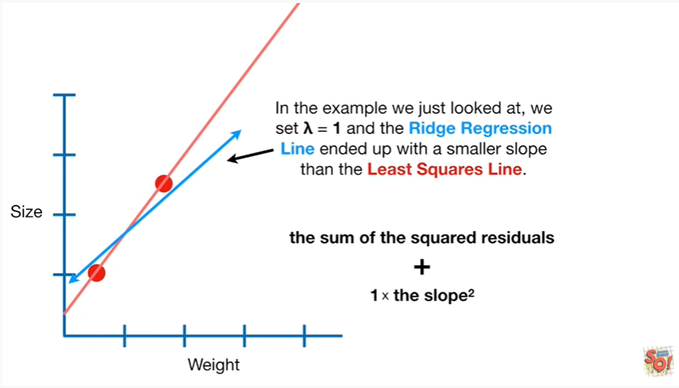

In the example we just looked at we said lambda equals 1 and the ridge regression line ended up with a smaller slope than the least squares line.

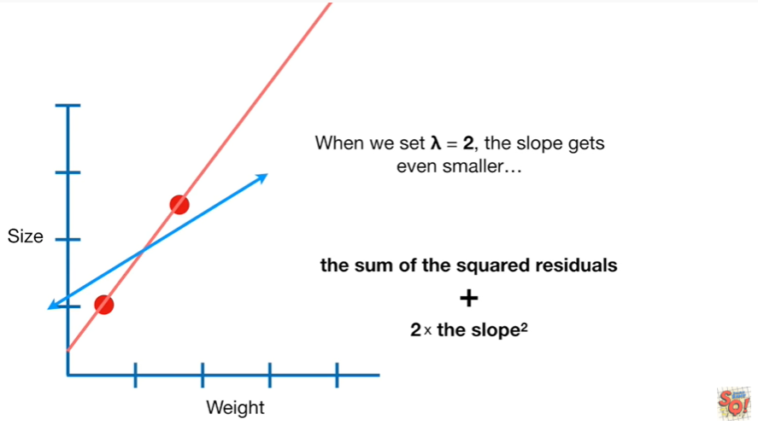

When we set lambda equals 2 the slope gets even smaller

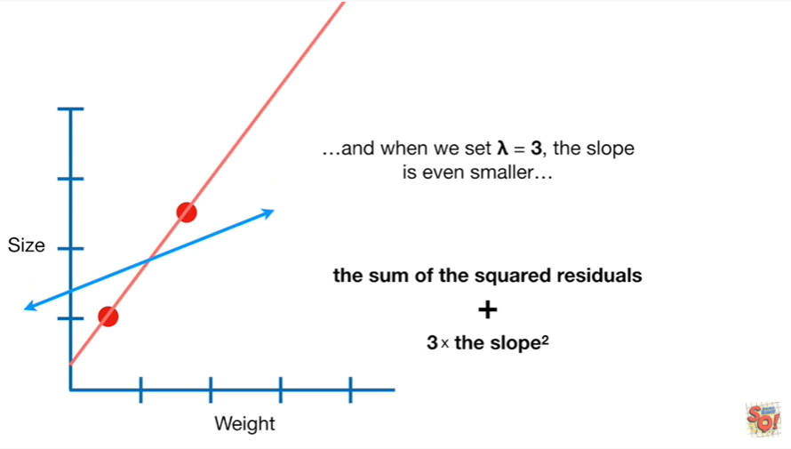

and when we set lambda equals 3 the slope is even smaller

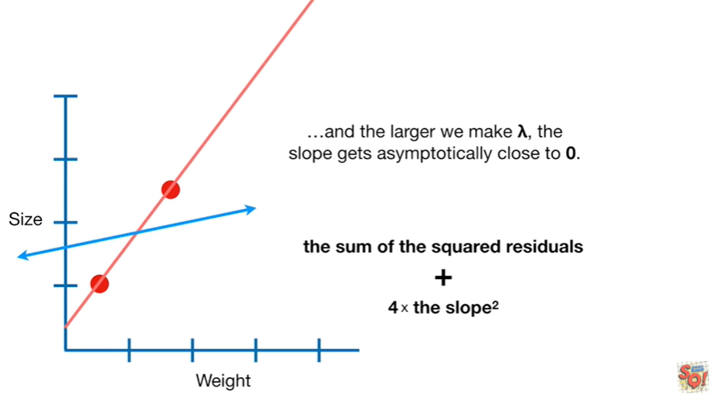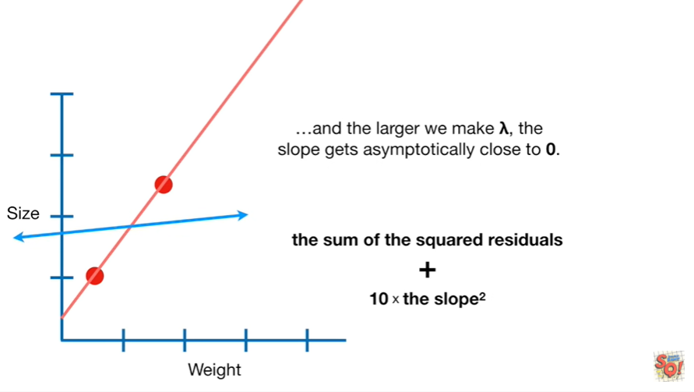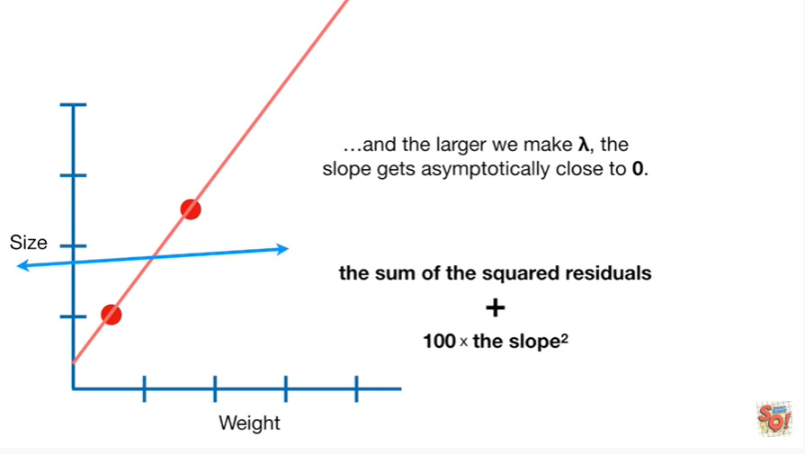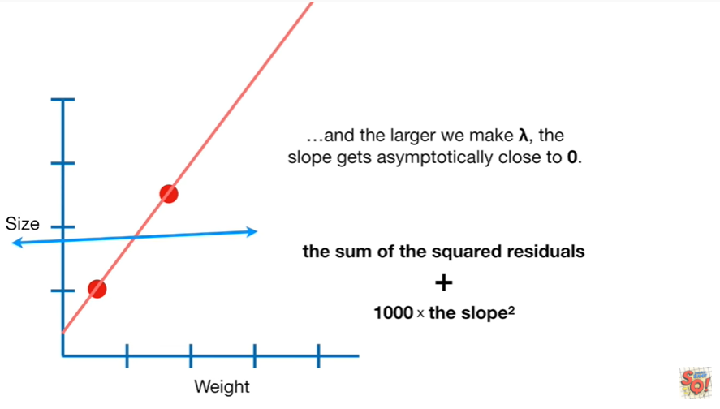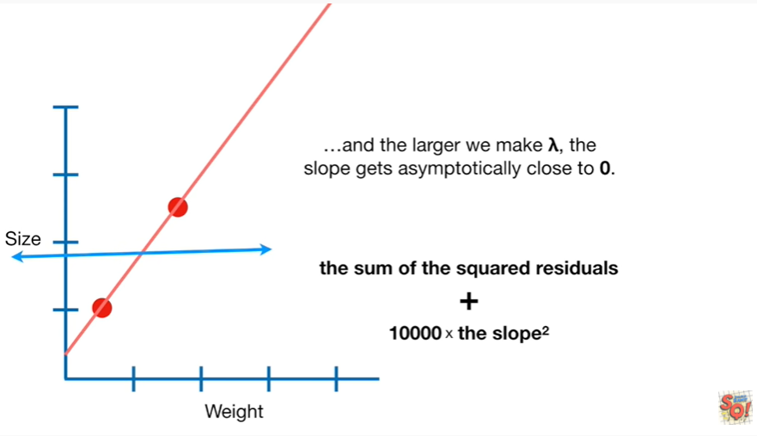

and the larger we make lambda the slope gets asymptotically close to 0

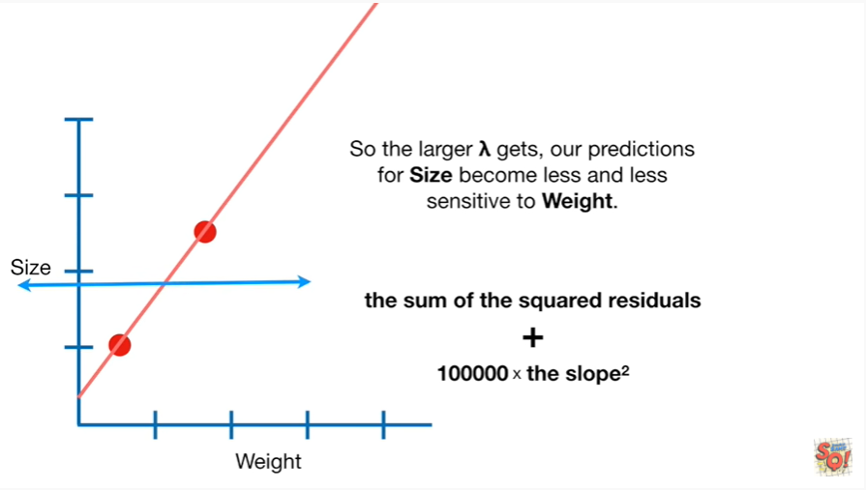

So the larger lambda gets our prediction for size become less and less sensitive to weight.

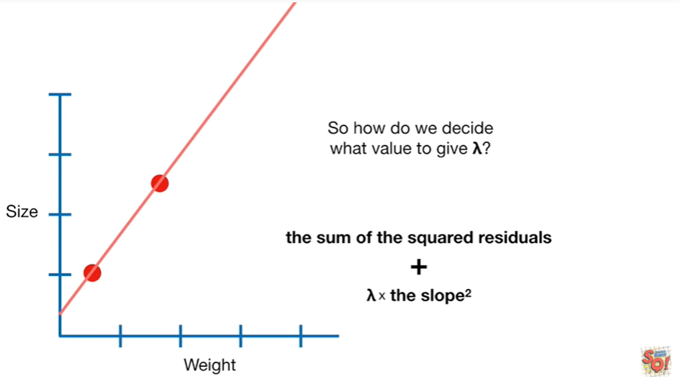

So how do we decide what value to give lambda ?

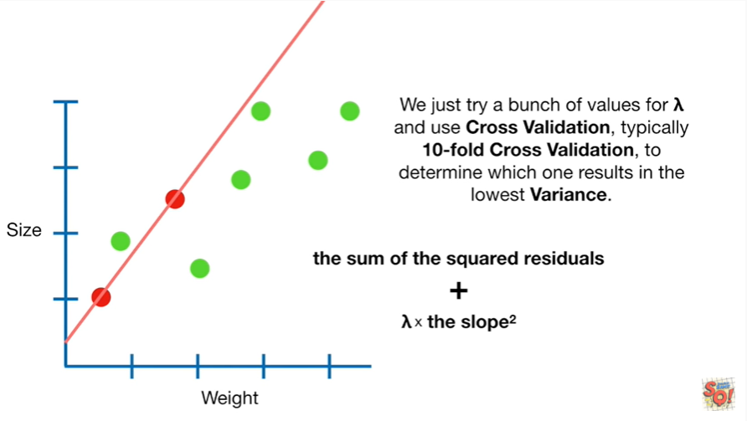

We just try a bunch of values for lambda and use cross-validation, typically 10-fold cross-validation, to determine which one results in the lowest variance.

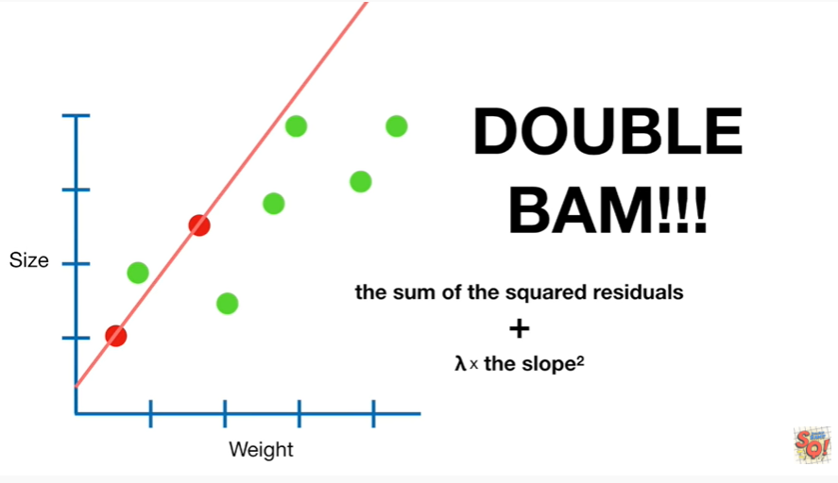

Double BAM !!!

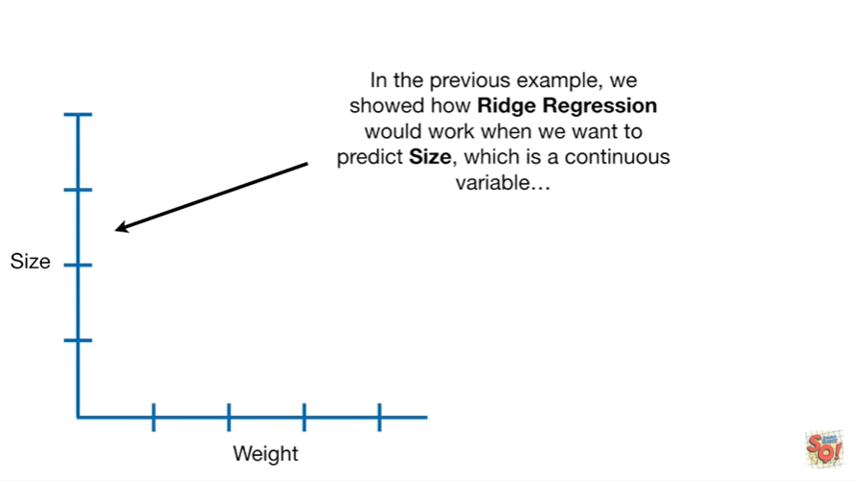

In the previous example we showed how ridge regression would work when we want to predict size which is a continuous variable

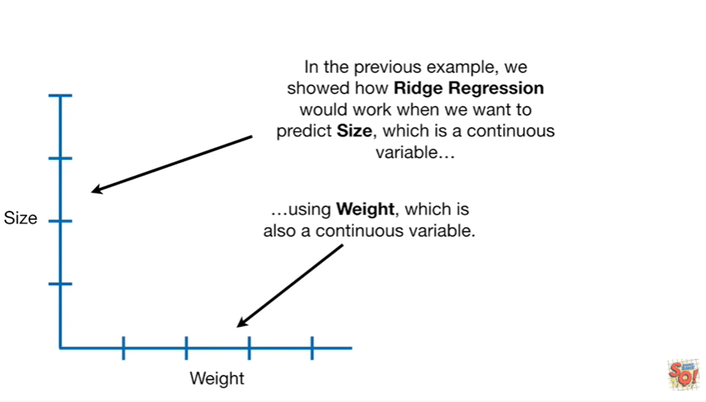

using weight which is also a continuous variable.

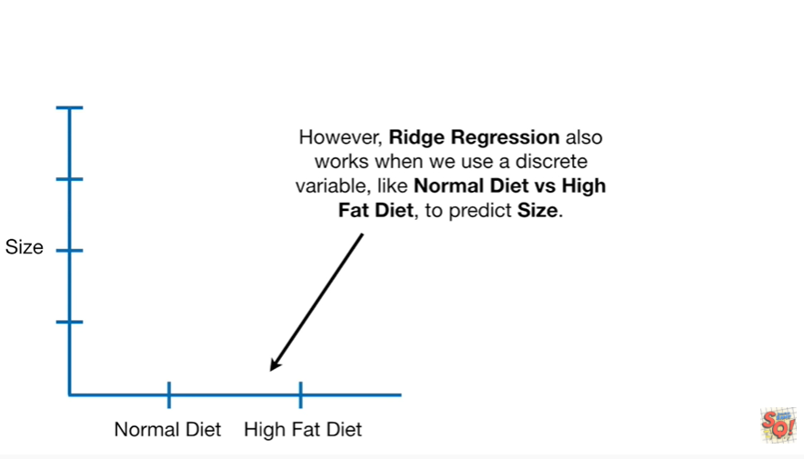

However Ridge regression also works when we use a discrete variable like normal diet versus high fat diet to predict size.

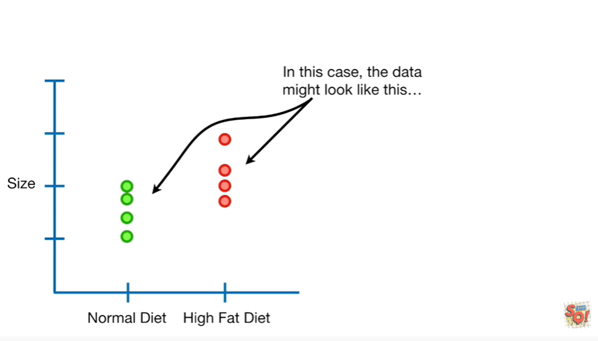

In this case the data might look like this

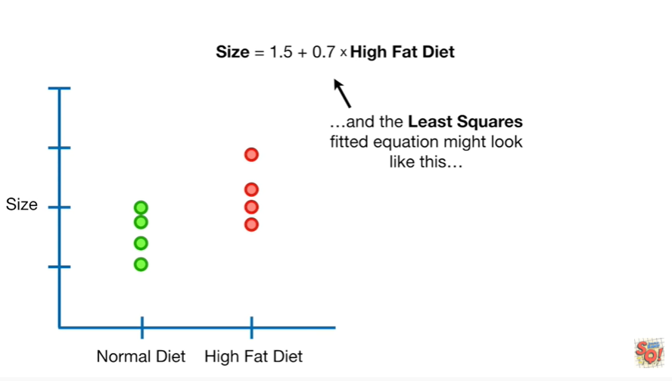

and the least squares fitted equation might look like this

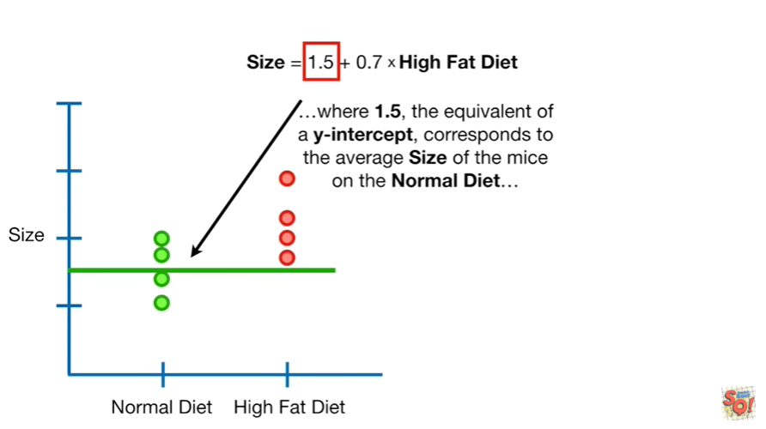

where 1.5 the equivalent of a y-intercept corresponds to the average size of the mice on the normal diet

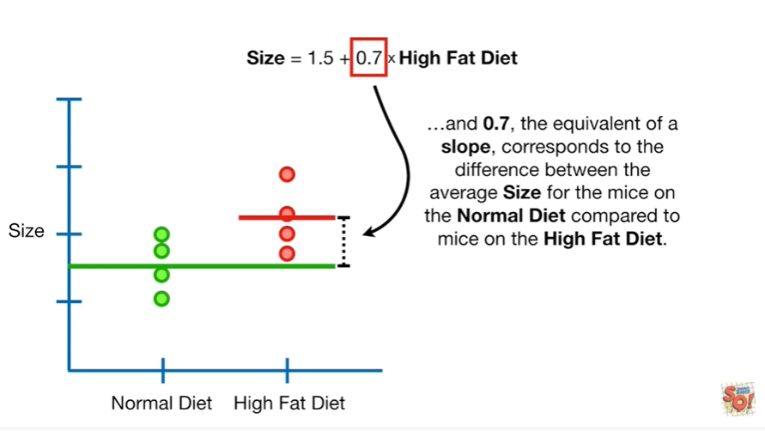

and 0.7 the equivalent of a slope corresponds to the difference between the average size for the mice on the normal diet compared to the mice on the high-fat diet .

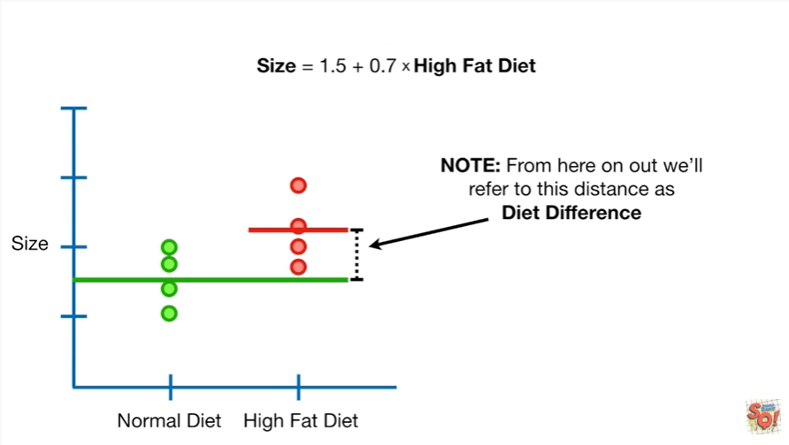

Note : from here on out we'll refer to this distance as diet difference.

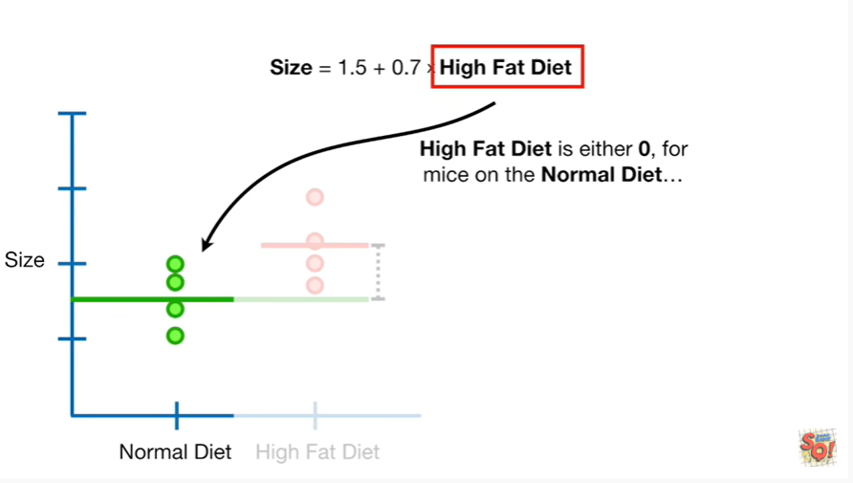

High-fat diet is either zero for mice on a normal diet

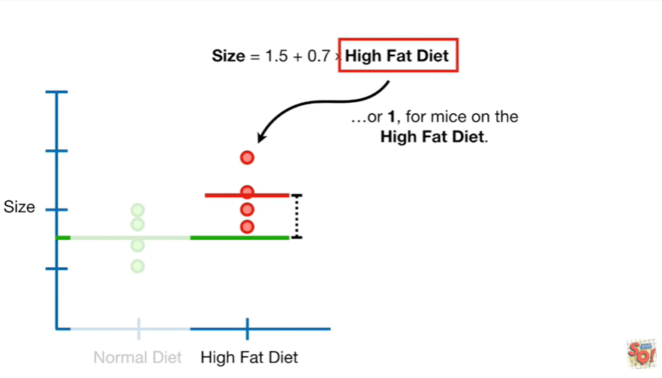

or one for mice on the high-fat diet.

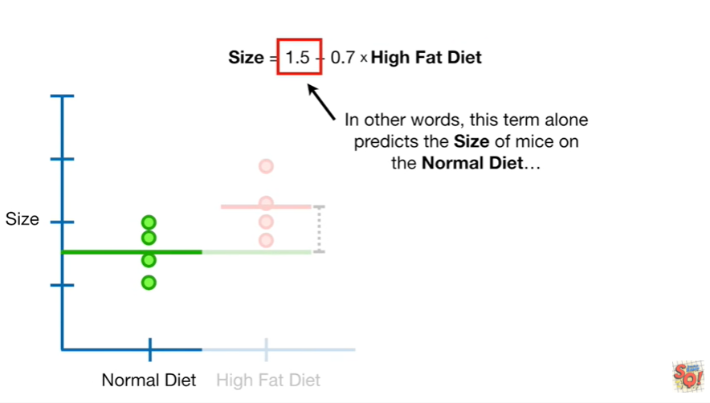

In other words this term alone predicts the size of mice on the normal diet.

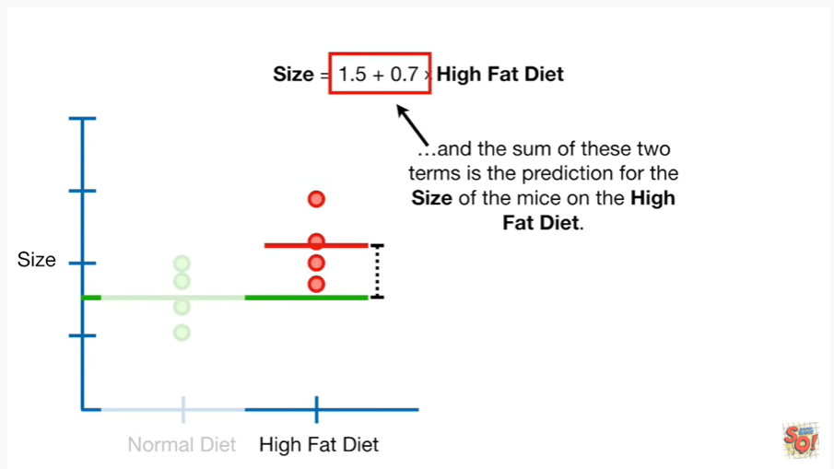

and the sum of these two terms is the prediction for the size of mice on the high-fat diet.

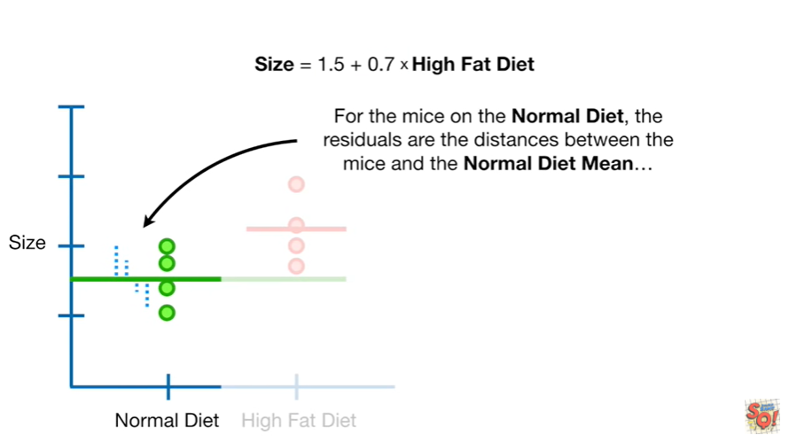

For the mice on the normal diet the residuals are the distances between the mice and the normal diet mean

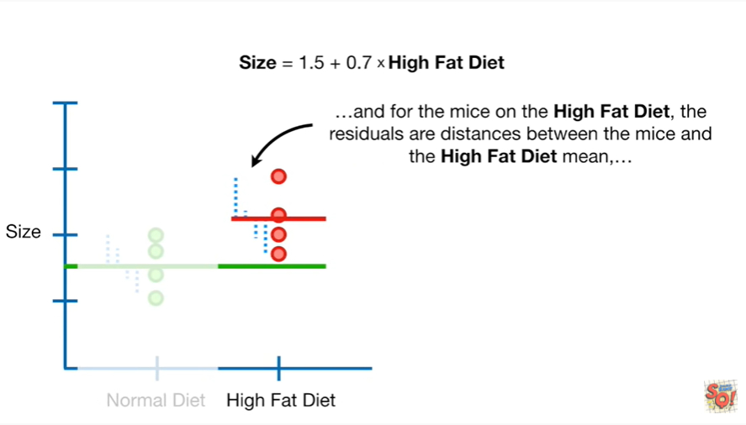

and for mice on the high-fat diet the residuals are the distances between the mice and the high fat diet mean.

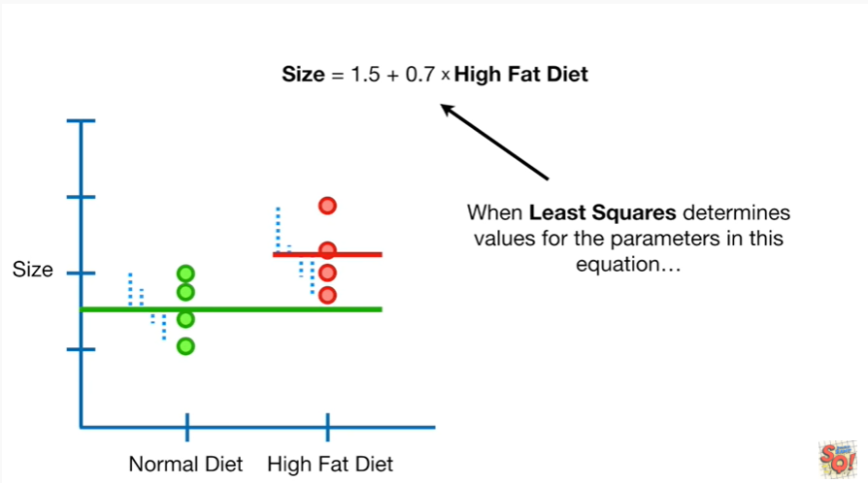

When Lee squares determines the values for the parameters in this equation

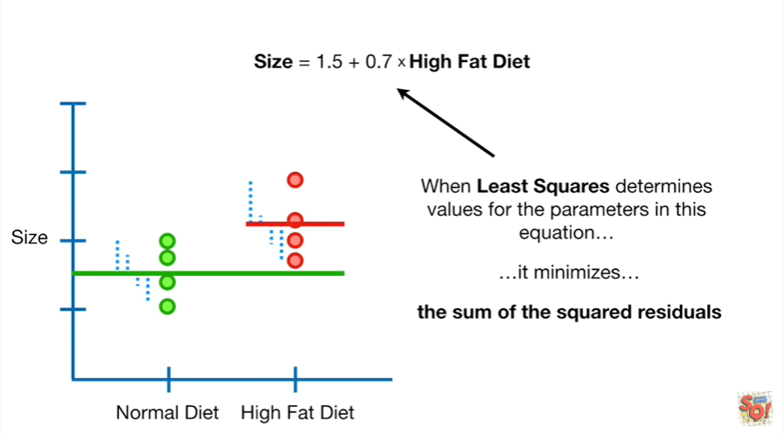

it minimizes the sum of the squared residuals.

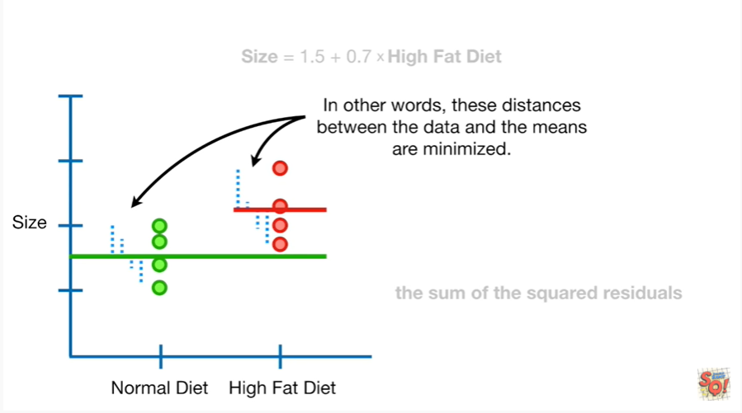

In other words these distances between the data and the means are minimized.

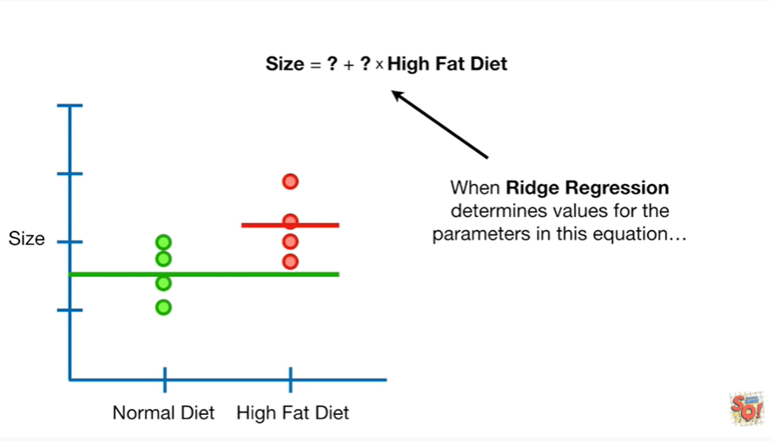

When Ridge regression determines values for the parameters in this equation

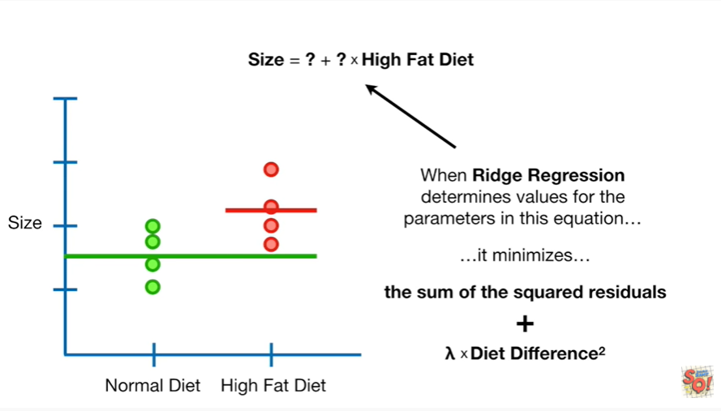

it minimizes the sum of the squared residuals plus lambda times diet difference squared.

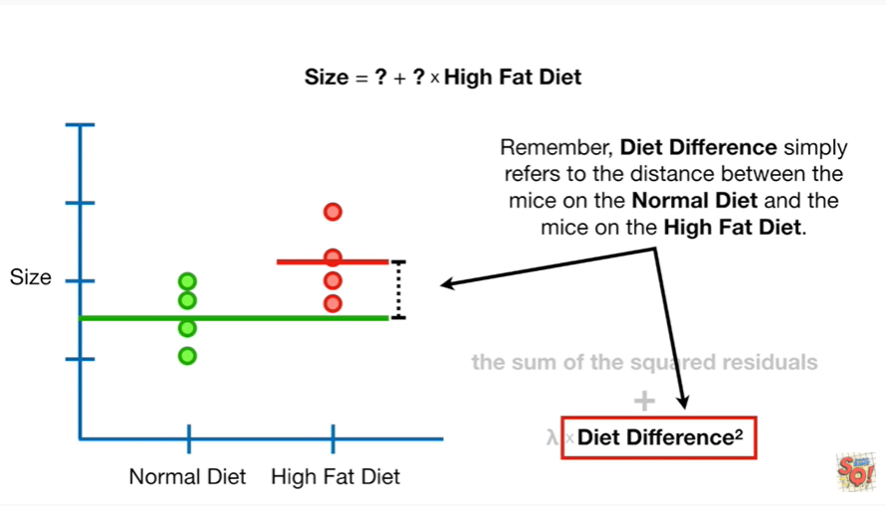

Remember diet difference simply refers to the distance between the mice on the normal diet and the mice on the high-fat diet.

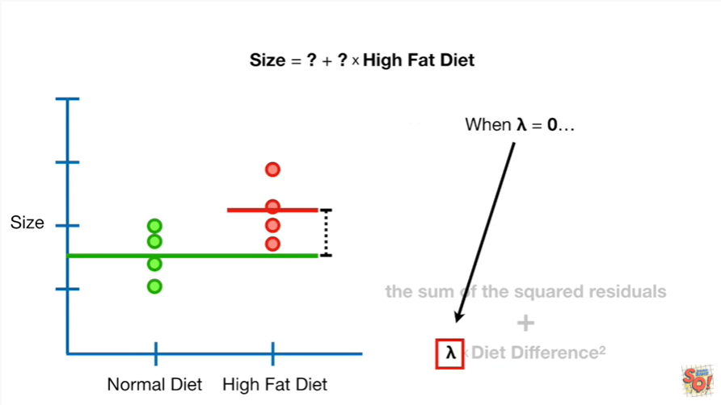

When lambda equals zero

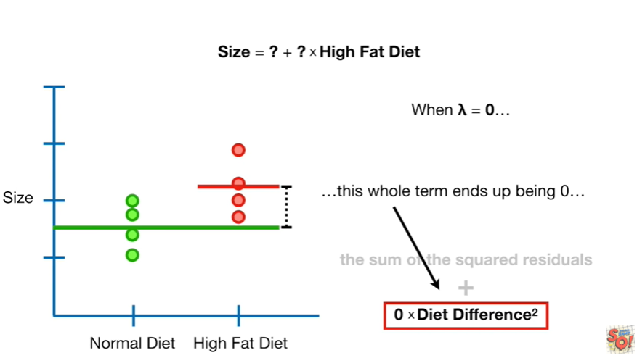

this whole term ends

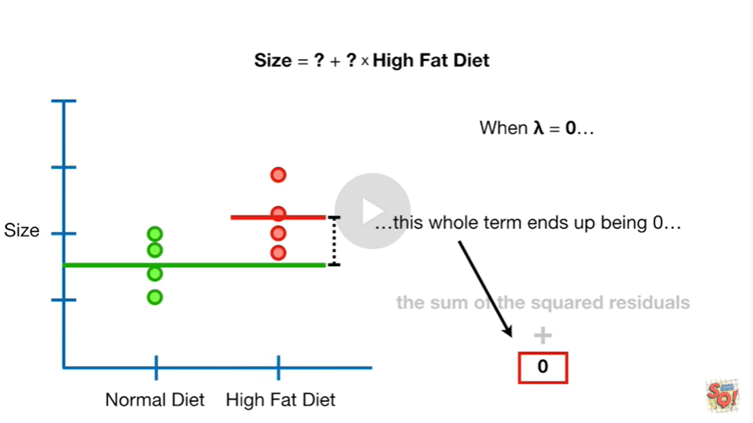

up being zero

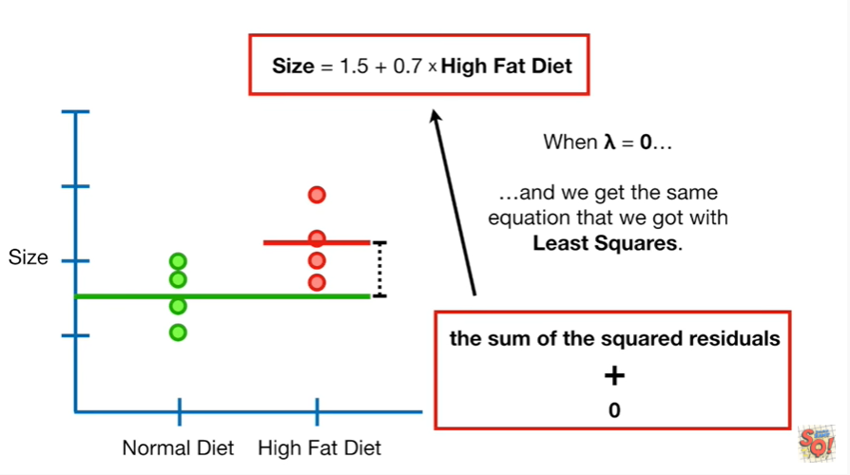

and we get the same equation that we got with least squares.

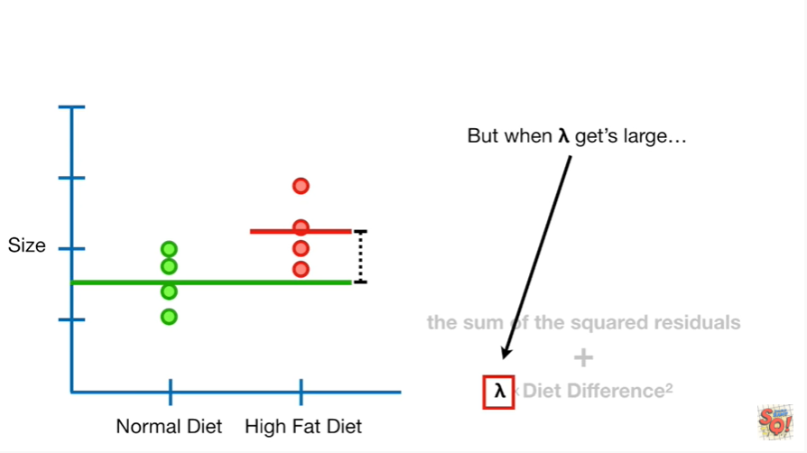

But when lambda gets large

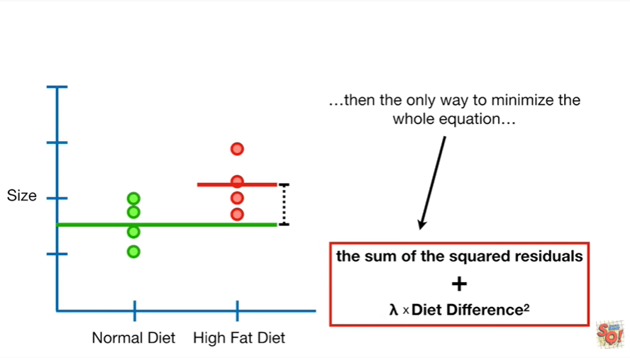

then the only way to minimize the whole equation

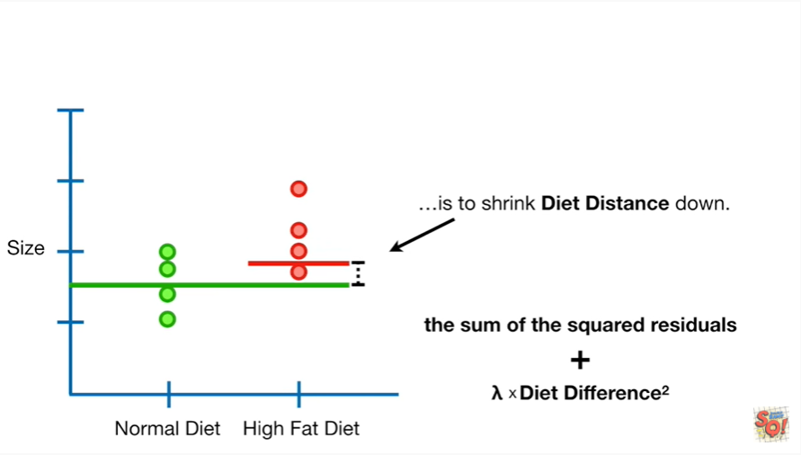

is to shrink diet distance down.

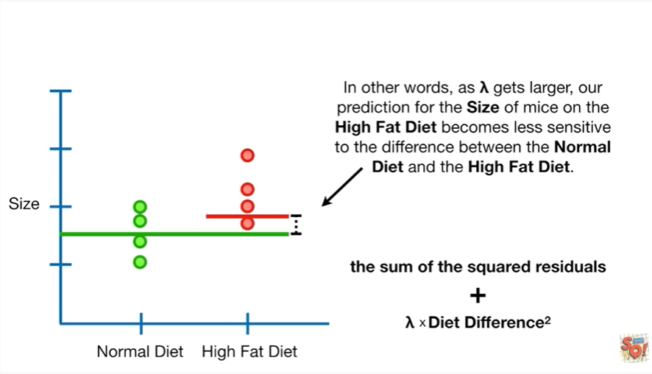

In other words as lambda gets larger our prediction for the size of mice on the high-fat diet becomes less sensitive to the difference between the normal diet and the high-fat diet

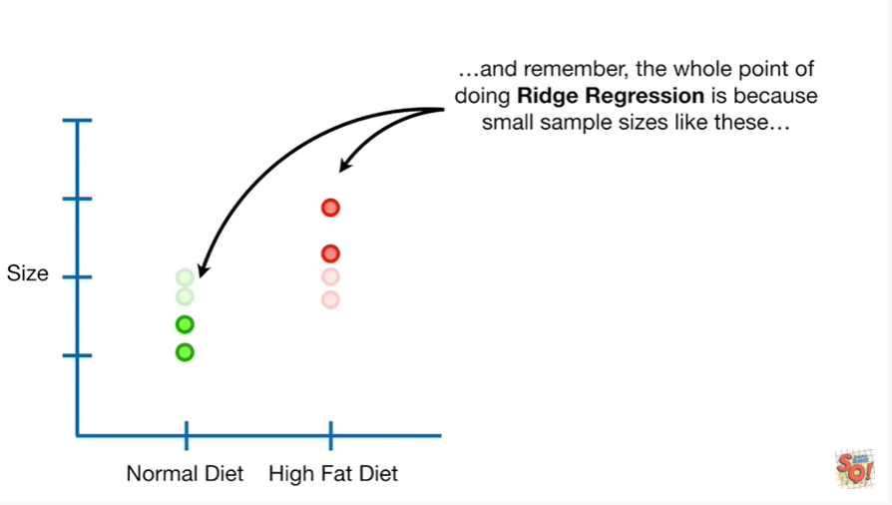

and remember the whole point of doing rich regression is because small sample sizes like these

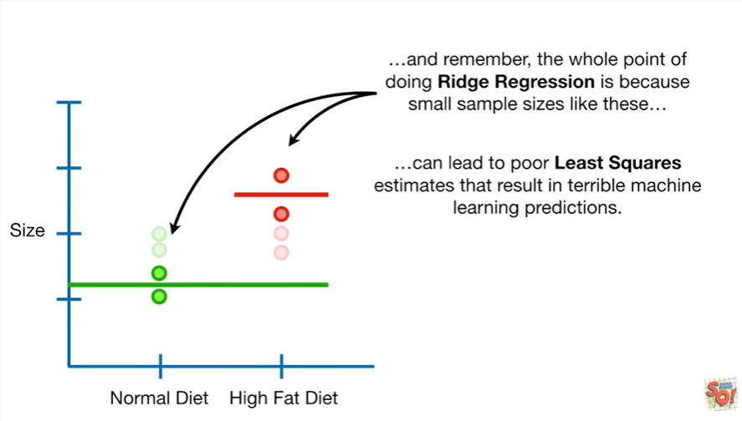

can lead to poor least squares estimates that result in terrible machine learning predictions.

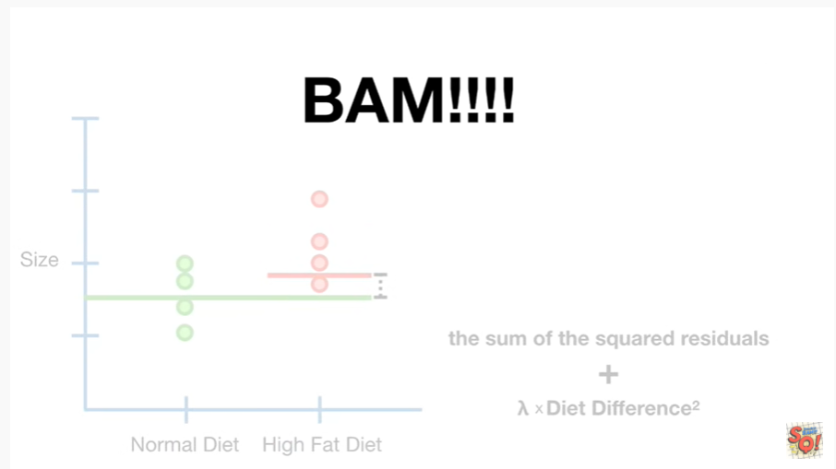

BAM !!!

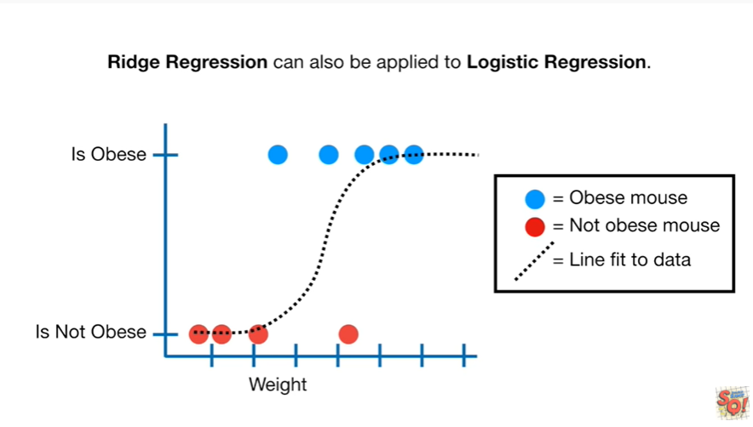

Ridge regression can also be applied to logistic regression.

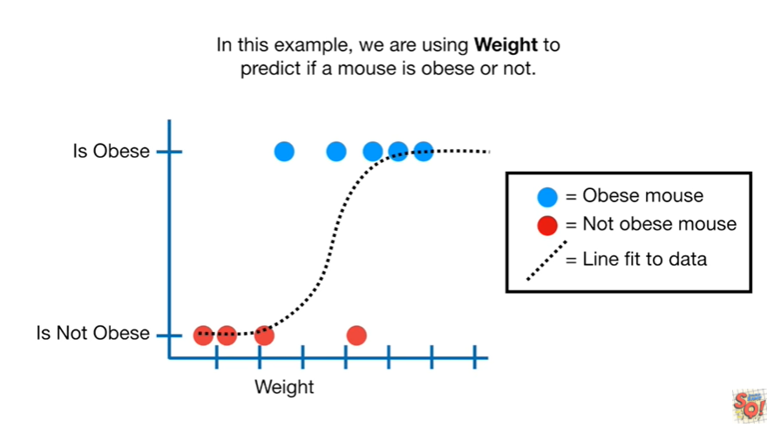

In this example we are using weight to predict if a mouse's obese or not.

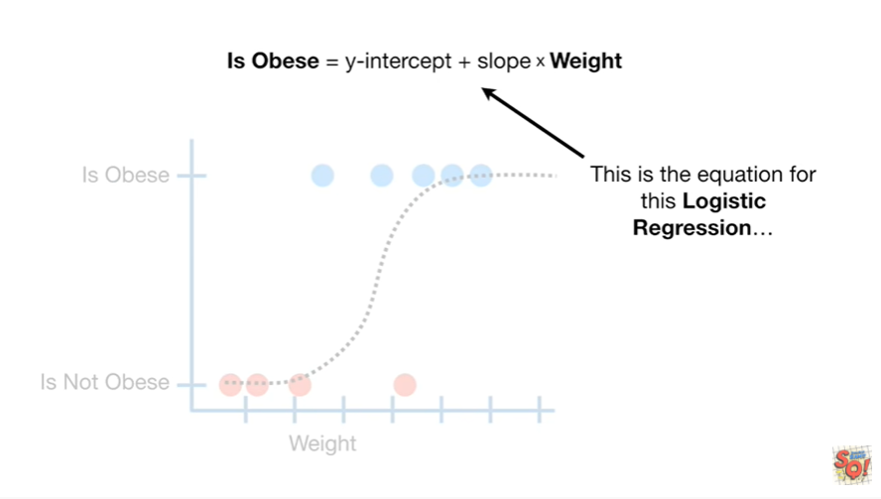

This is the equation for this logistic regression

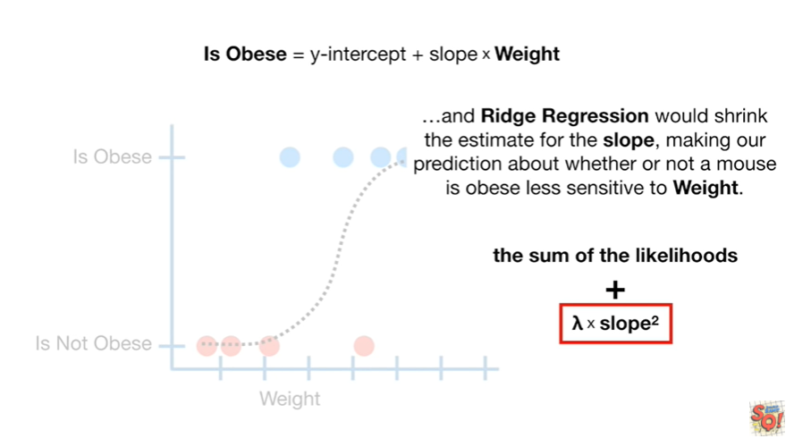

and Ridge regression would shrink the estimate for the slope making our prediction about whether and out of mouse is obese less sensitive to weight.

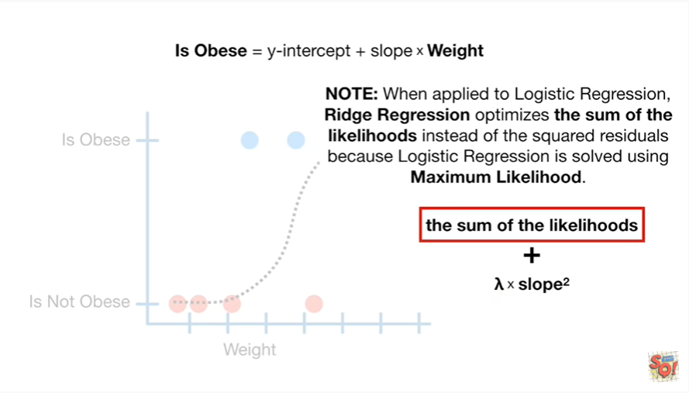

Note : when applied to logistic regression Ridge regression optimizes the sum of the likelihoods instead of the squared residuals because logistic regression is solved using maximum likelihood.

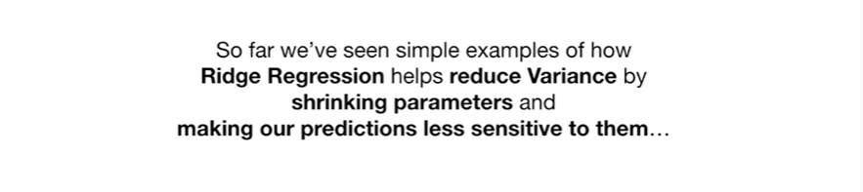

So far we've seen simple examples of how Ridge regression helps reduce variance by shrinking parameters and making our predictions less sensitive to them.

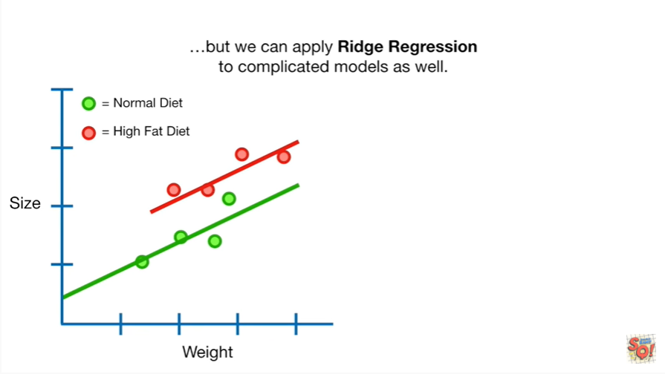

But we can apply Ridge regression to complicated models as well.

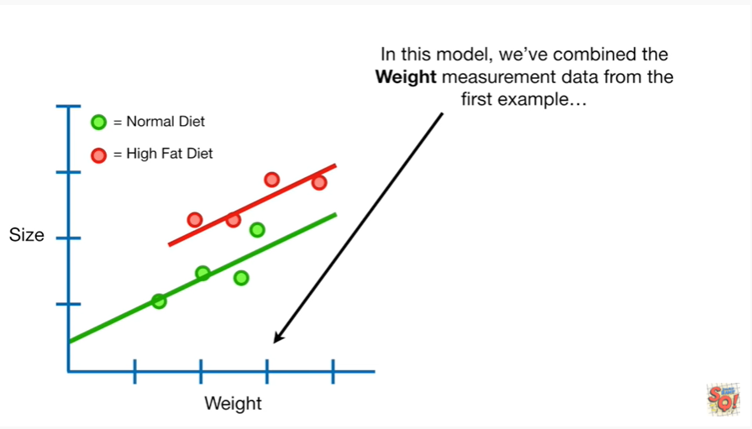

In this model we've combined the weight measurement data from the first example

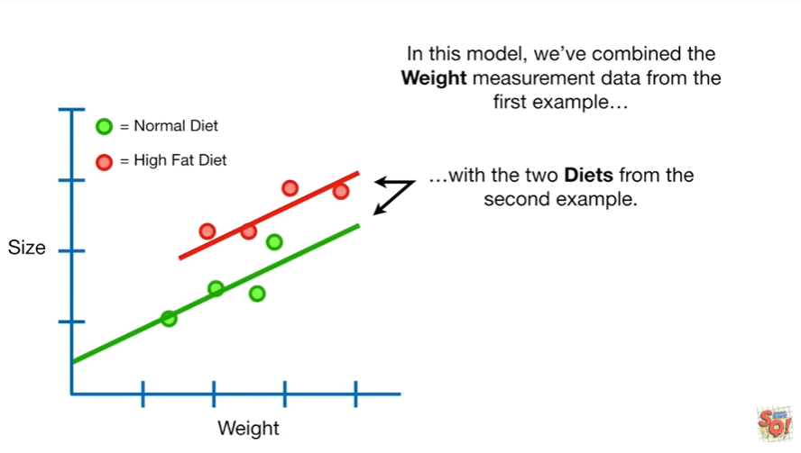

with the two diets from the second example.

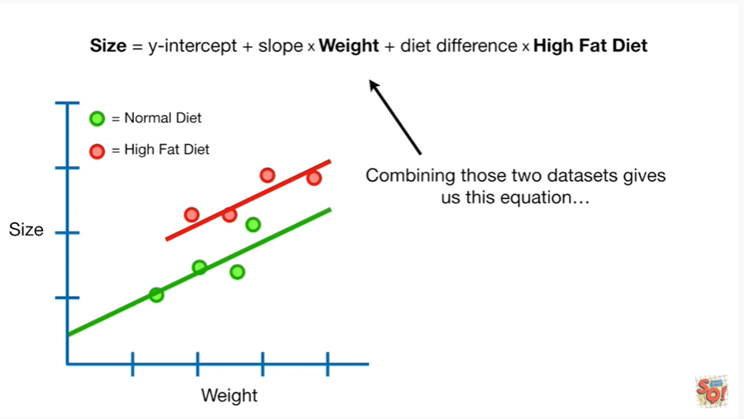

Combining these two datasets gives us this equation

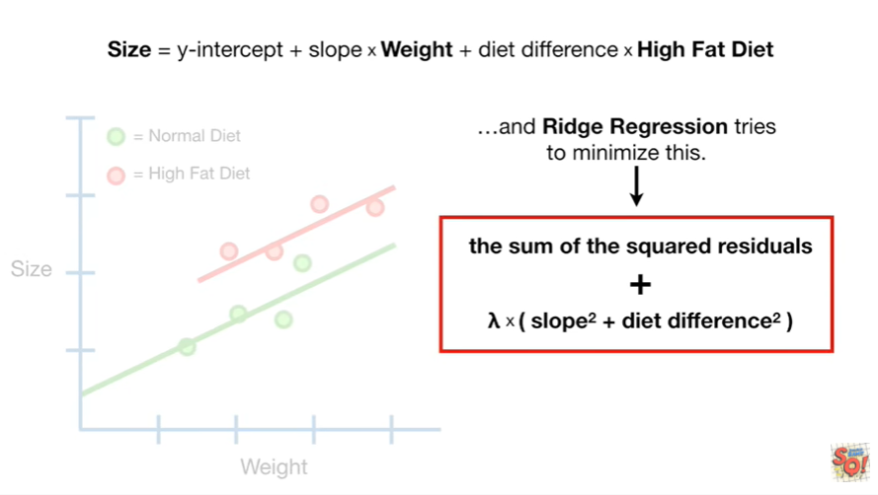

and Ridge regression tries to minimize this.

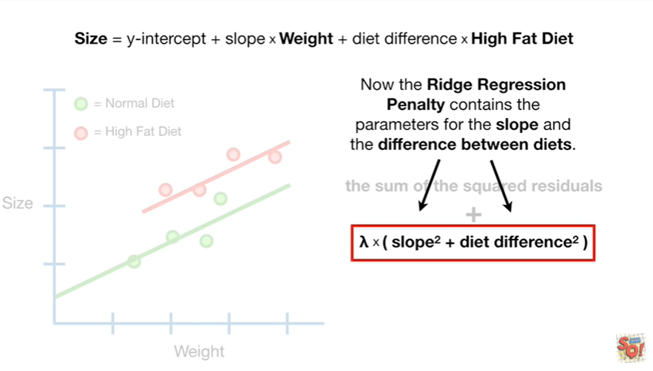

Now the ridge regression penalty contains the parameters for the slope and the difference between diets.

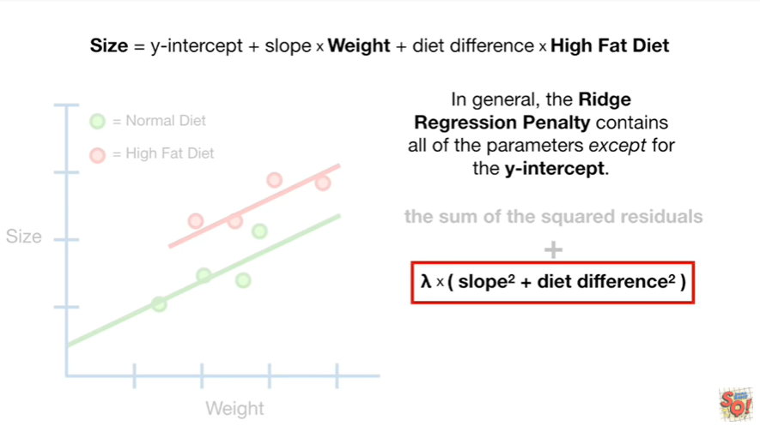

In general the ridge regression penalty contains all of the parameters except for the y intercept.

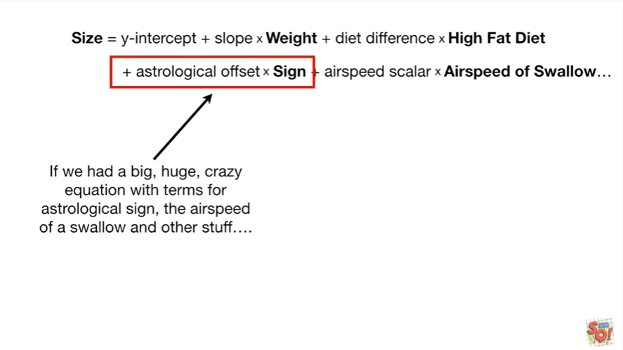

If we had a big huge crazy equation with terms for astrological sign

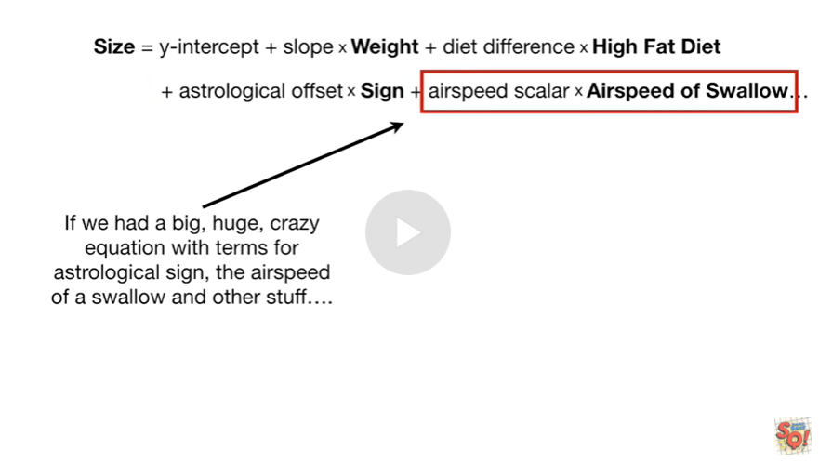

the airspeed of a swallow and other stuff.

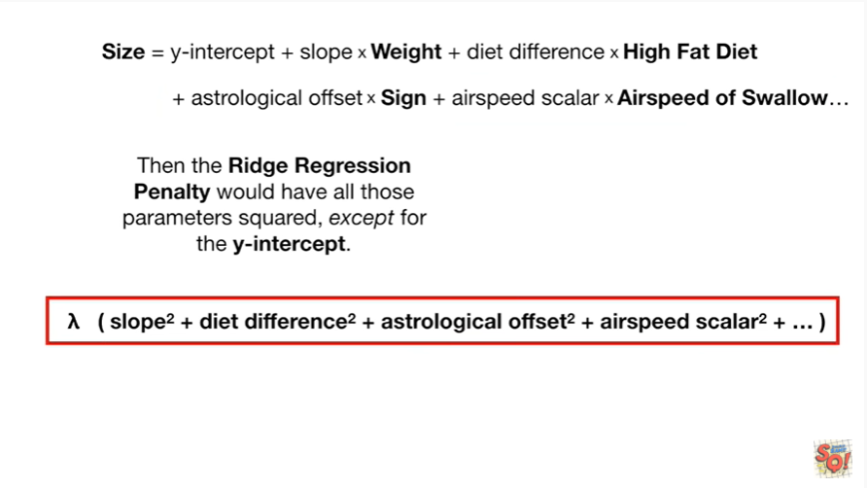

Then the ridge regression penalty would have all those parameters squared except for the y intercept.

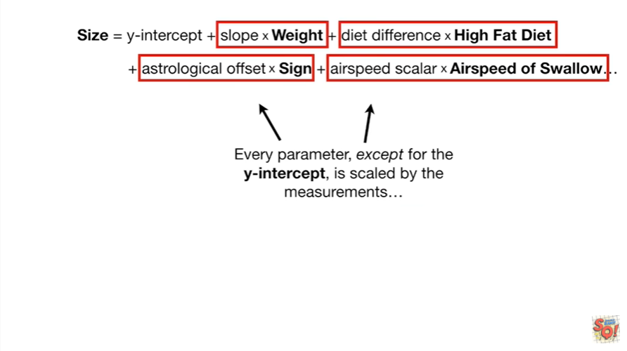

Every parameter except for the y intercept is scaled by the measurements

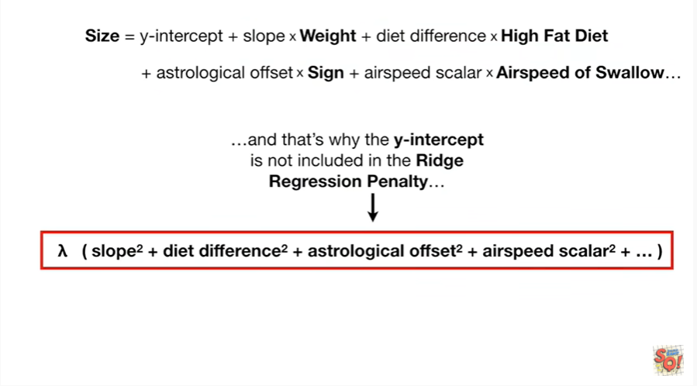

and that's why the y intercept is not included in the ridge regression penalty.



Double bam !!!

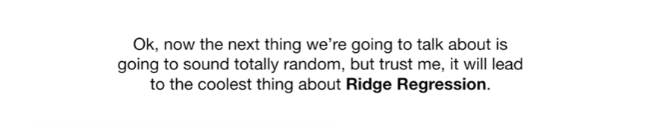

Okay now the next thing we're going to talk about is going to sound totally random but trust me it will lead to the coolest thing about Ridge regression.

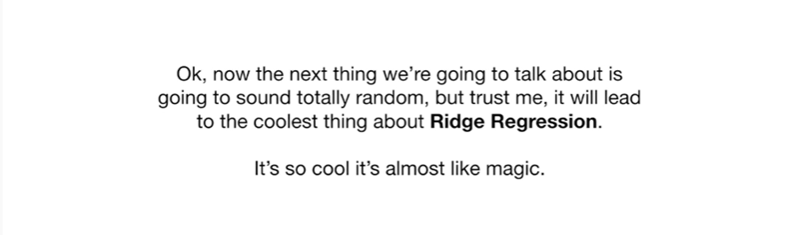

It's so cool it's almost like magic.

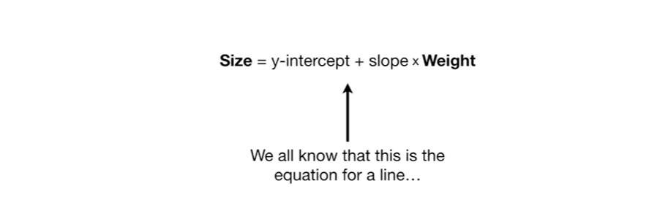

We all know that this is the equation for a line

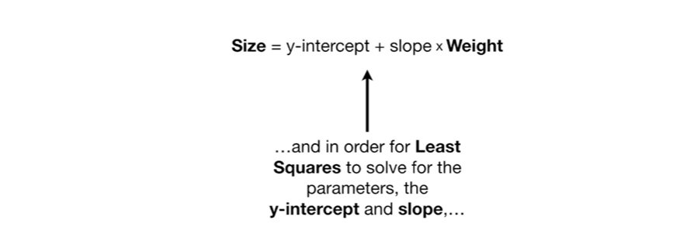

and in an order for least squares to solve for the parameters the y-intercept and slope

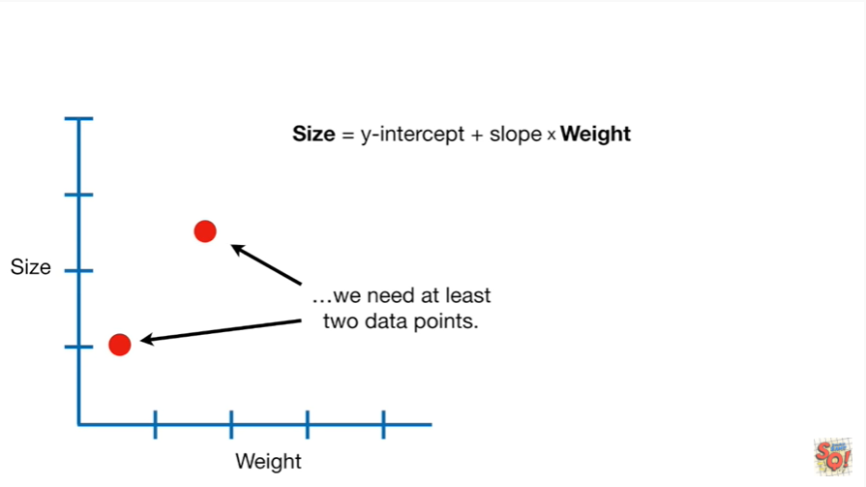

we need at least two data points.

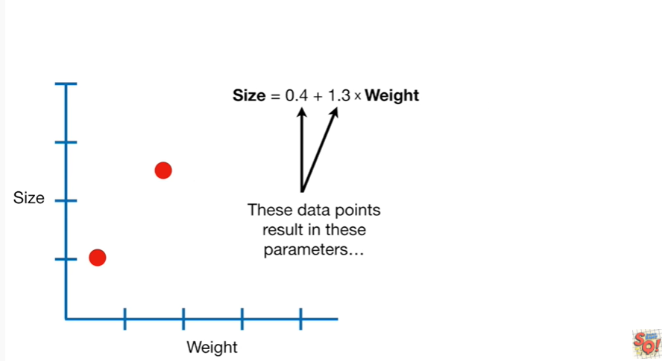

These data points result in these parameters

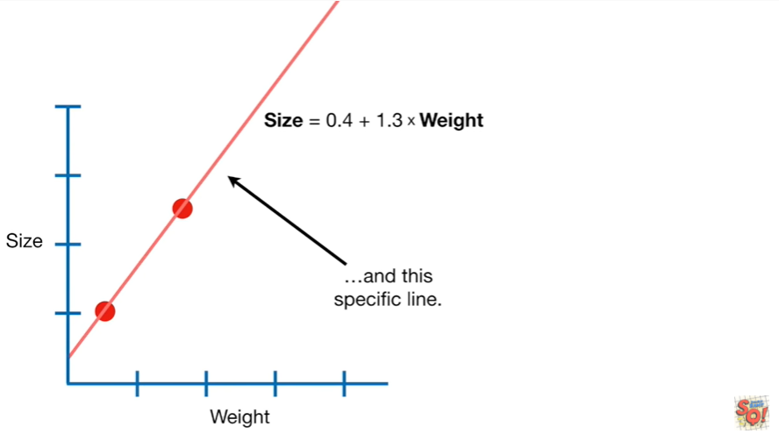

and this specific line.

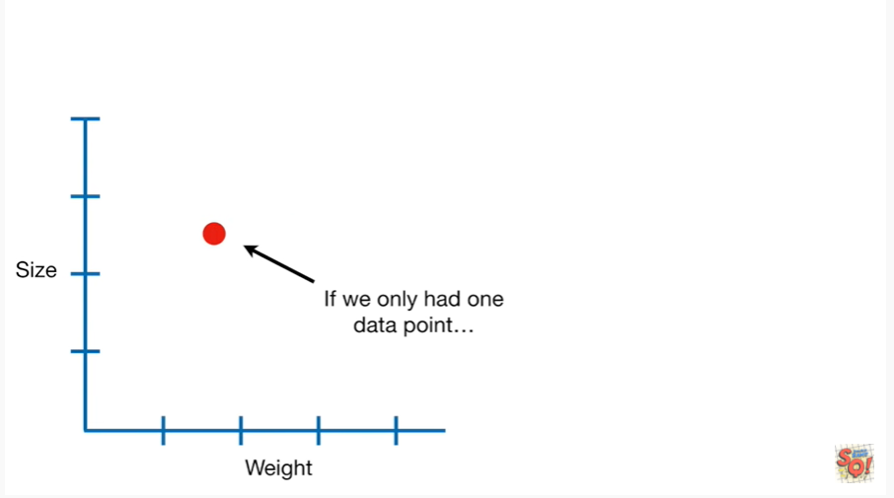

If we only have one data point

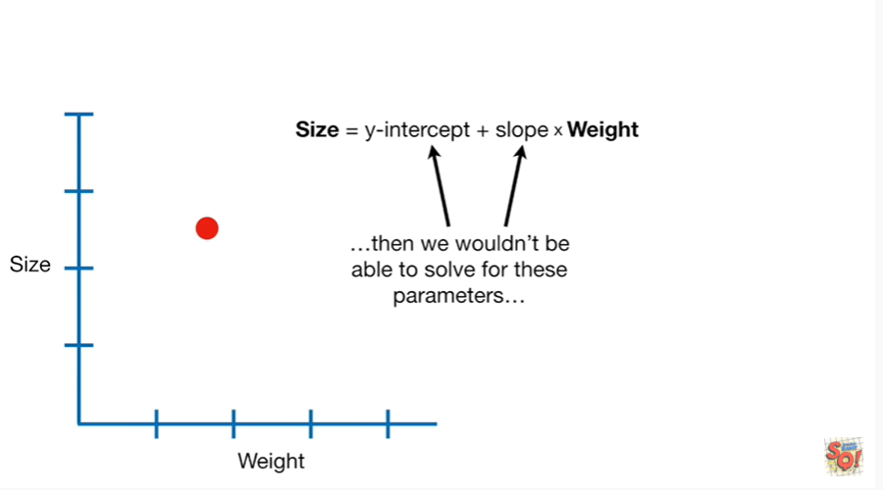

then we wouldn't be able to solve for these parameters

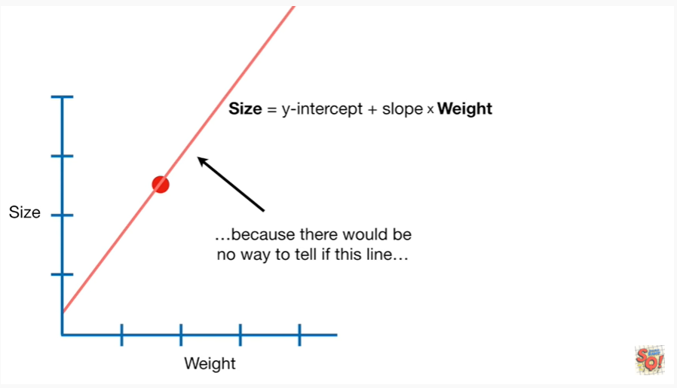

because there would be no way to tell if this line

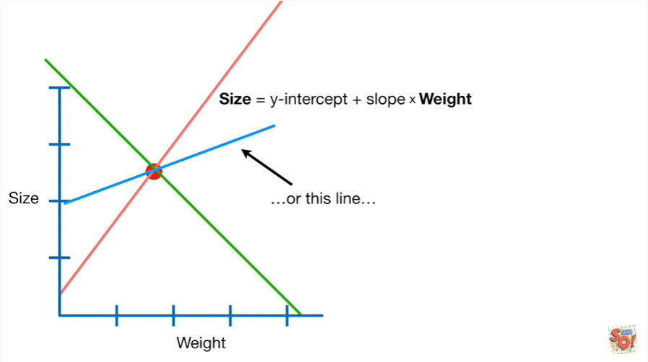

is better than this line

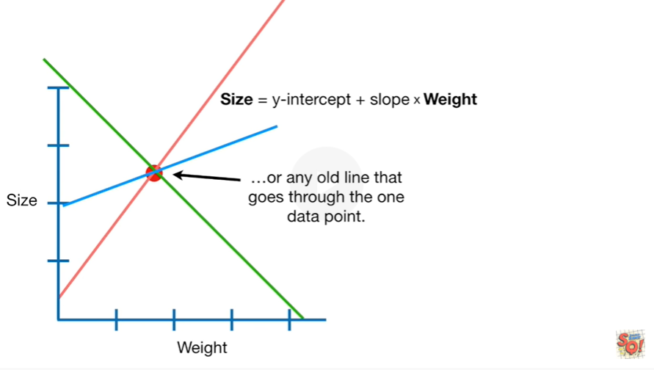

or this line or any old line that goes through the one data point.

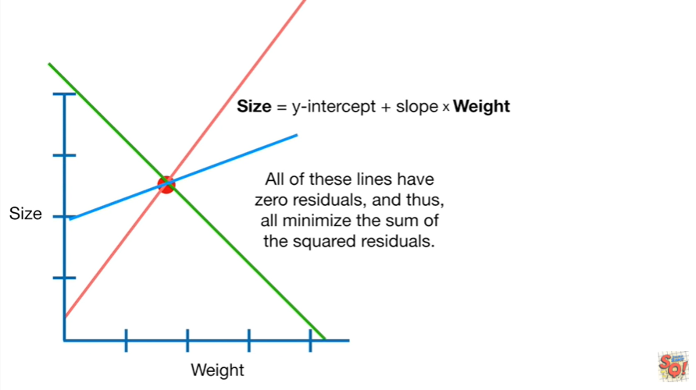

All of these lines have zero residuals and thus all minimize the sum of the squared residuals.

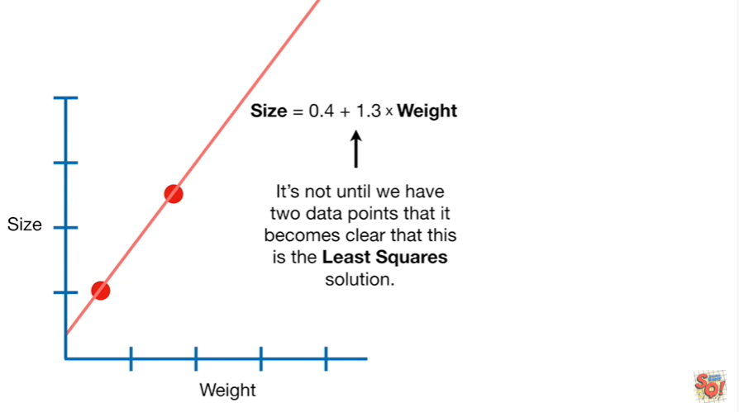

It's not until we have two data points that it becomes clear that this is the least square solution.

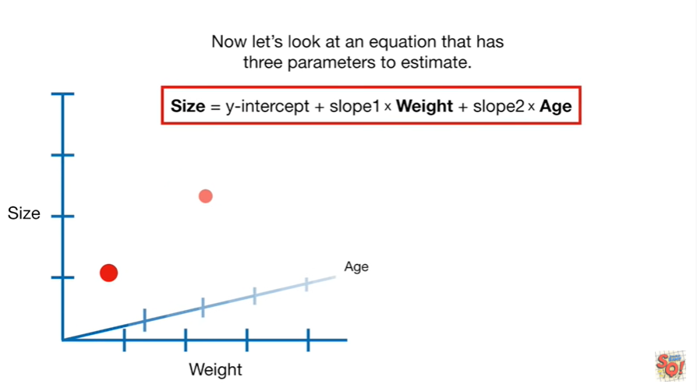

Now let's look at an equation that has three parameters to estimate.

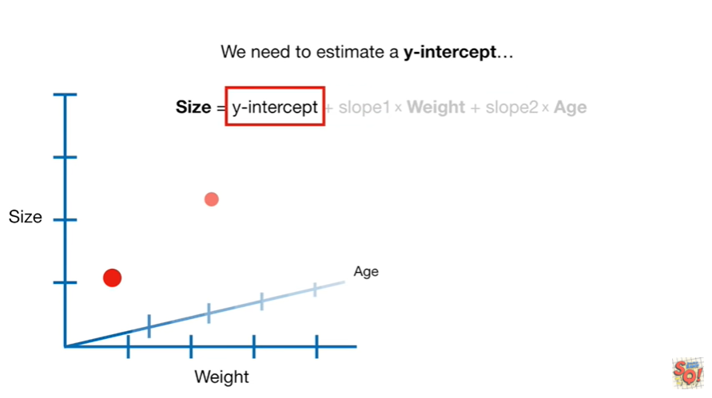

We need to estimate a y-intercept

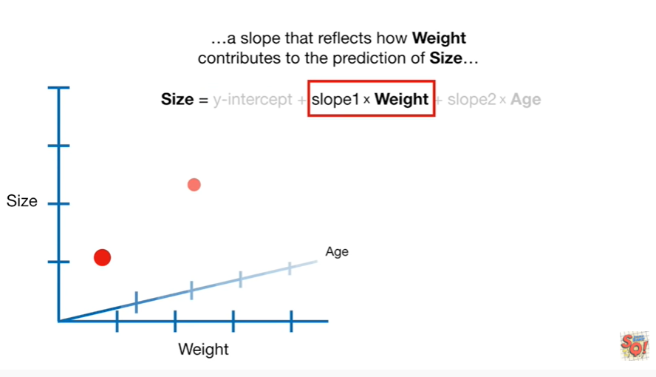

a slope that reflects how weight contributes to the prediction of size

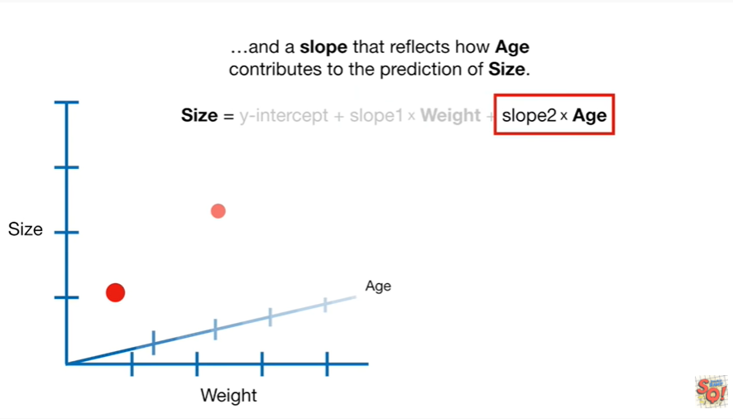

and a slope that reflects how age contributes to the prediction of size.

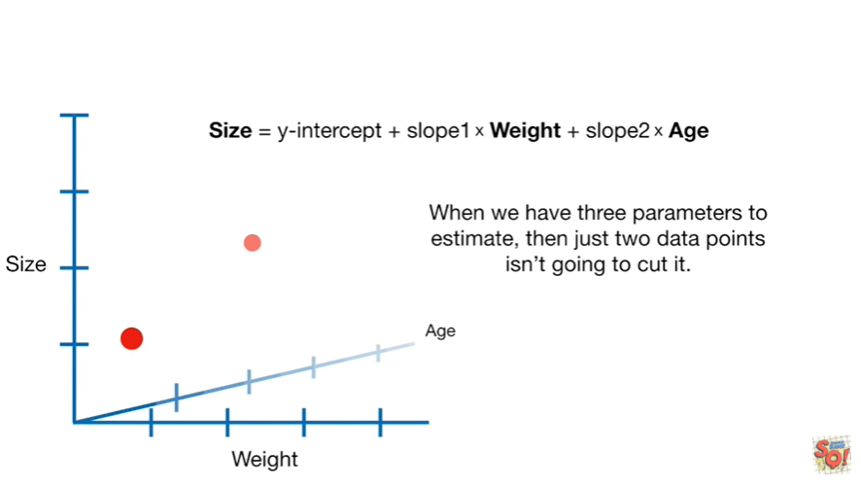

When we have three parameters to estimate then just two data points isn't going to cut it.

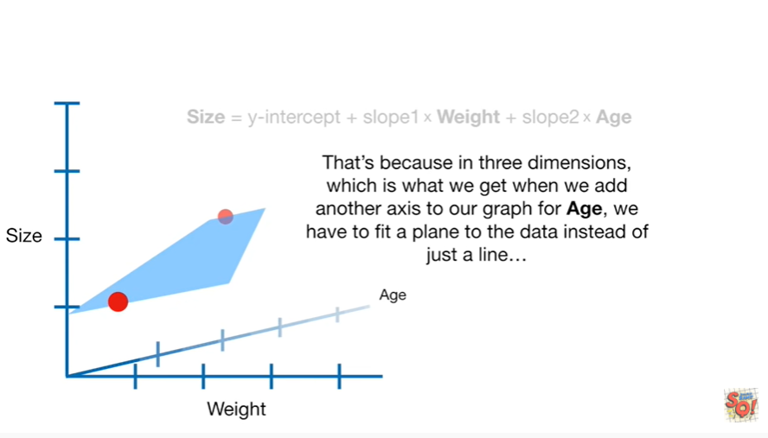

That's because in three dimensions which is what we get when we add another access to our graph for age we have to fit a plane to the data instead of just a line

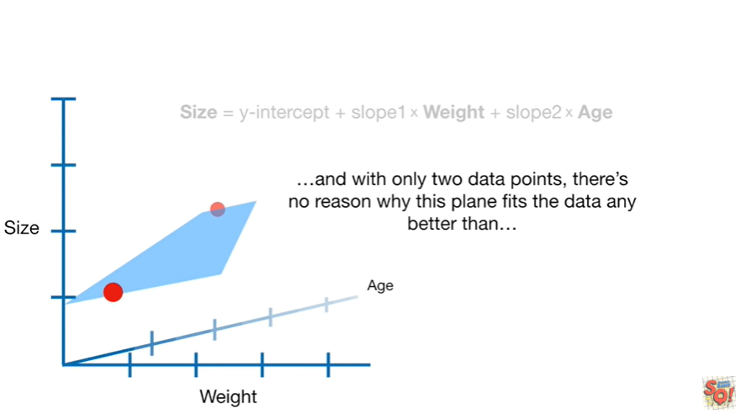

and with only two data points there's no reason why this plane fits the data any better than

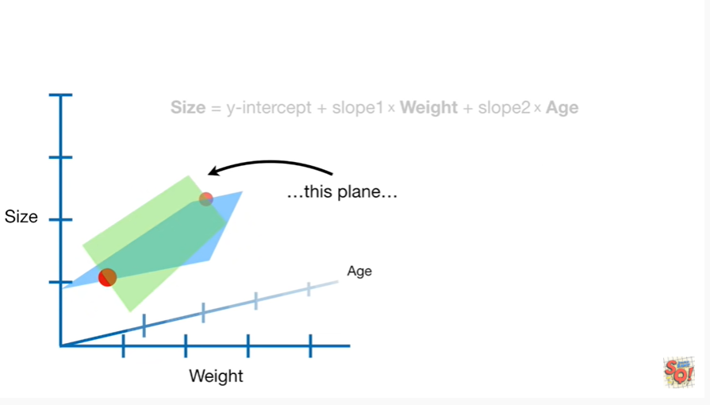

this plane

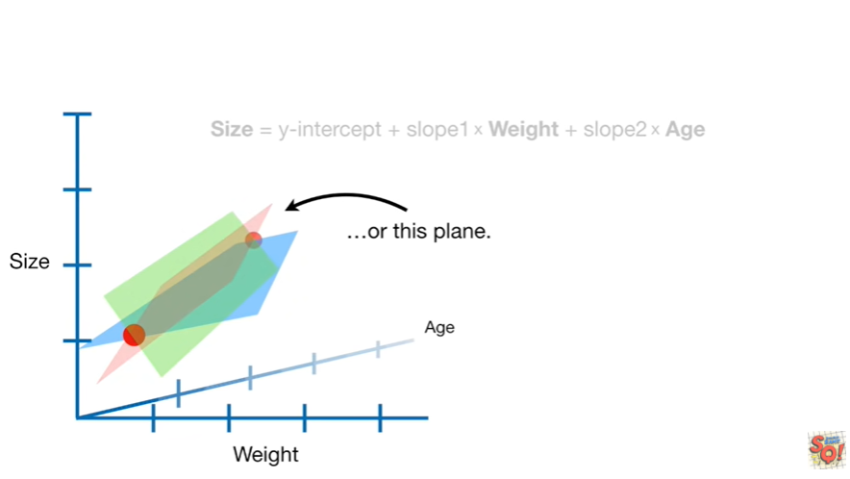

or this plane

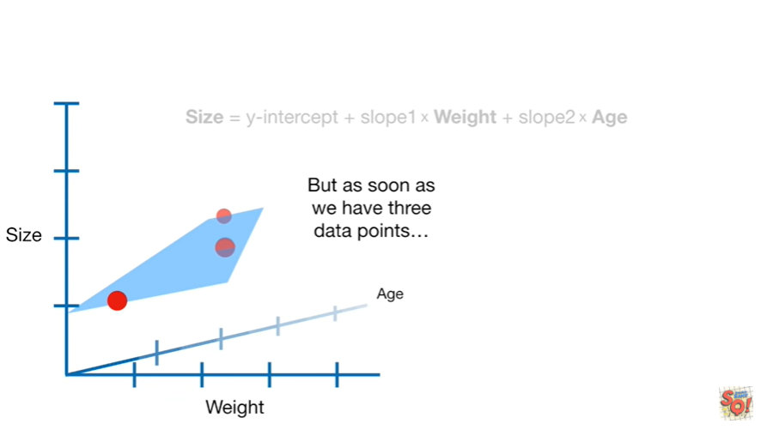

but as soon as we have three data points

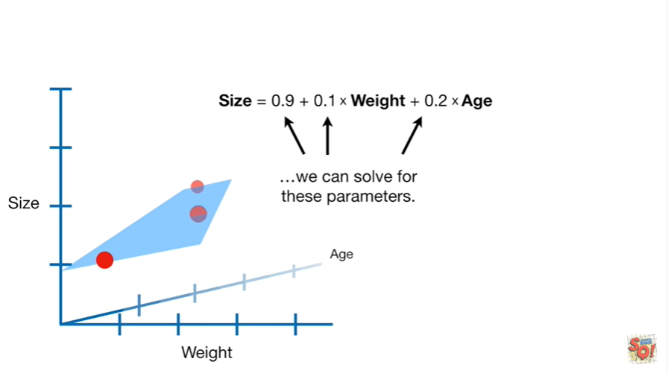

we can solve for these parameters.

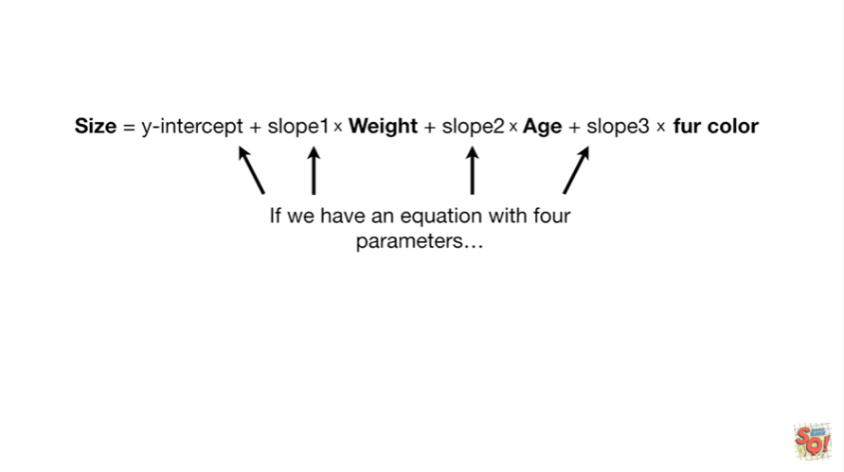

If we have an equation with four parameters

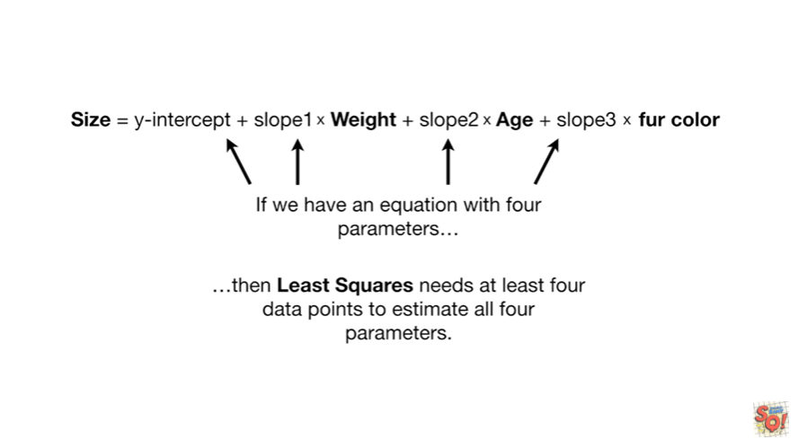

then least squares needs at least four data points to estimate all four parameters.

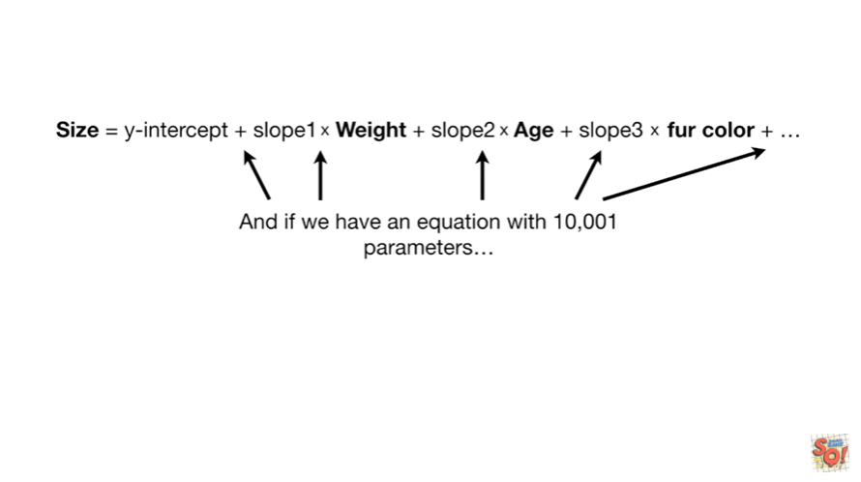

And if we have an equation with 10,001 parameters

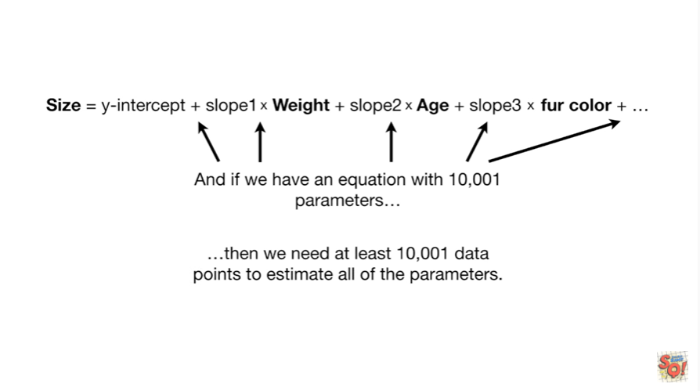

then we need at least 10,000 and one data points to estimate all of the parameters.

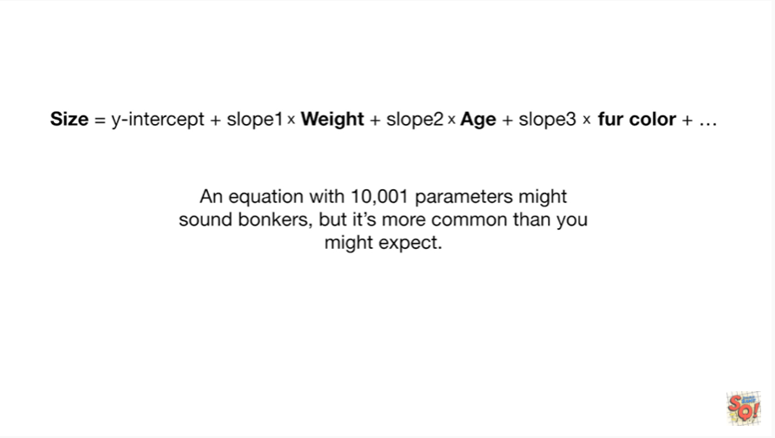

An equation with 10,001 parameters might sound bonkers but it's more common than you might expect.

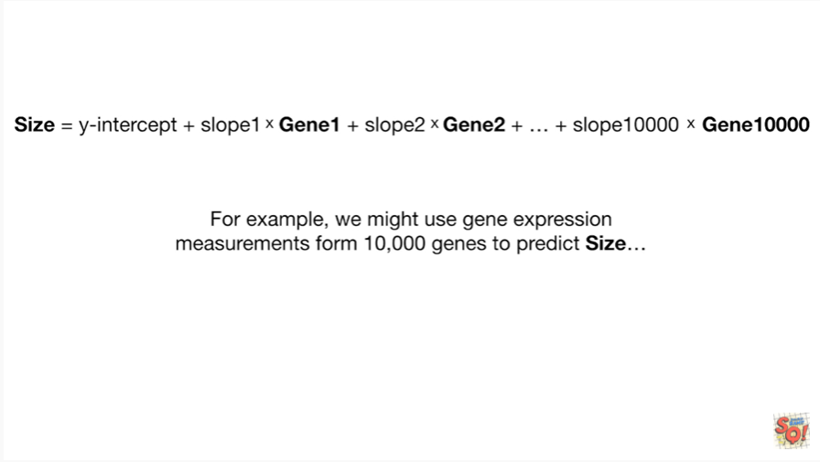

For example we might use gene expression measurements from 10,000 genes to predict size

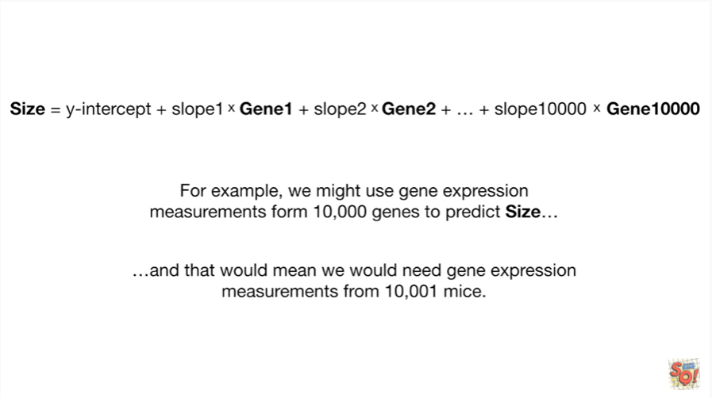

and that would mean we would need gene expression measurements from ten thousand and one mice.

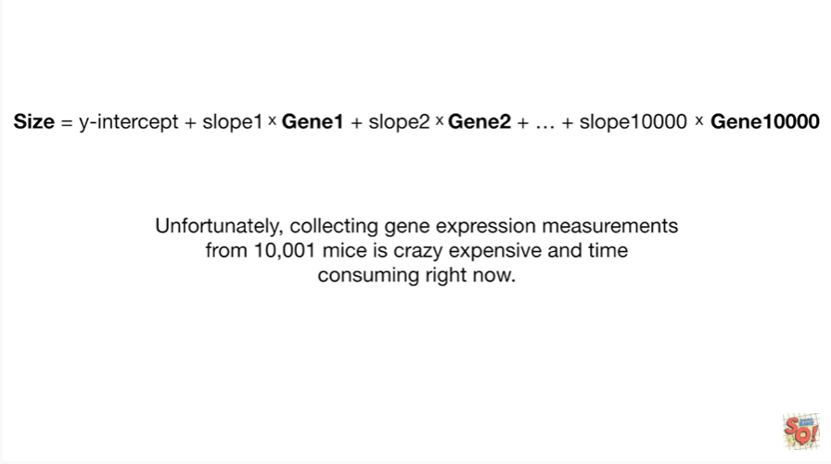

Unfortunately collecting gene expression measurements from ten thousand and one mice is crazy expensive and time-consuming right now.

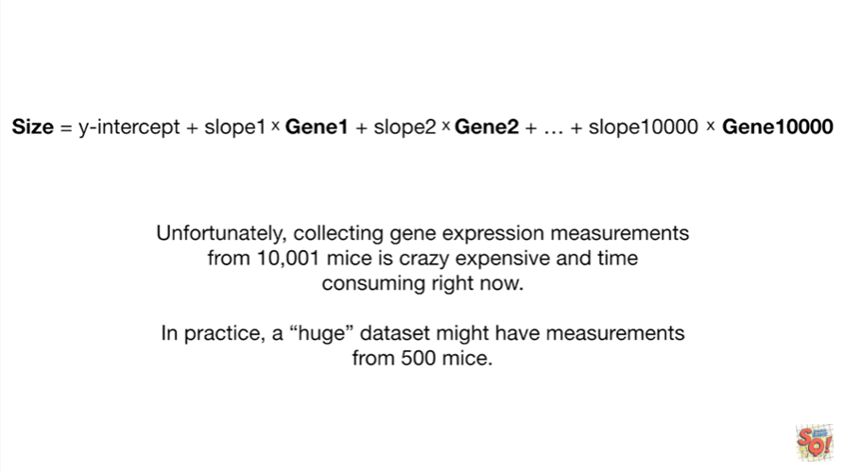

In practice a huge data set might have measurements from 500 mice.

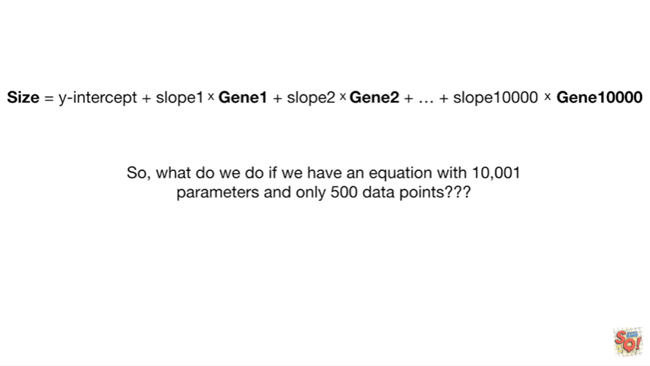

So what do we do if we have an equation with ten thousand and one parameters in only 500 data points ?

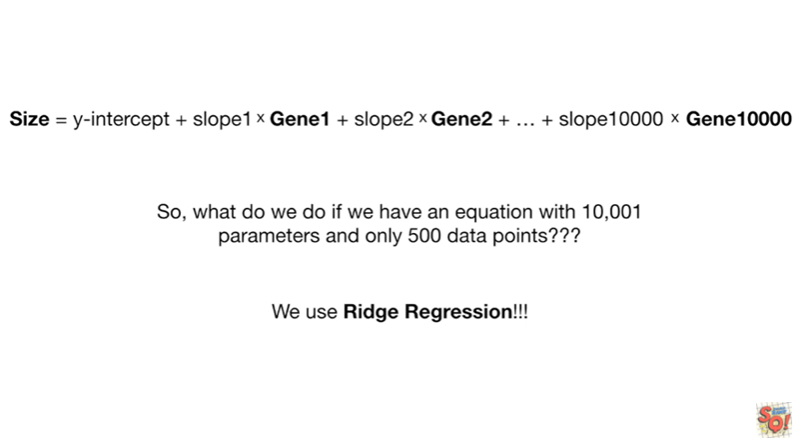

We use Ridge regression.

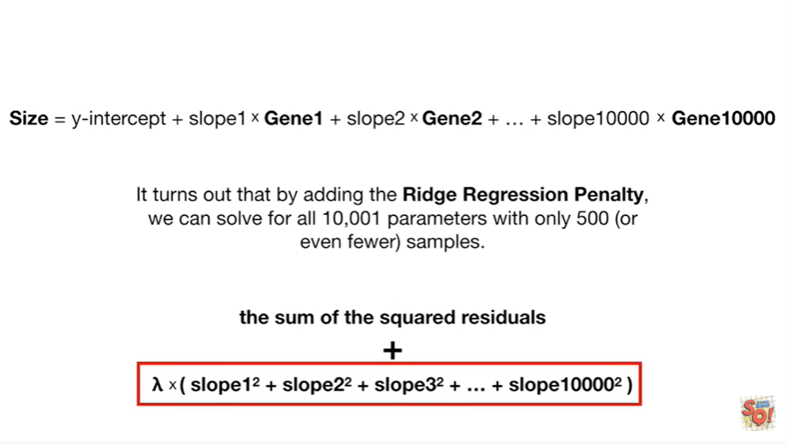

It turns out that by adding the ridge regression penalty we can solve for all 10,000 won parameters with only 500 or even fewer samples.

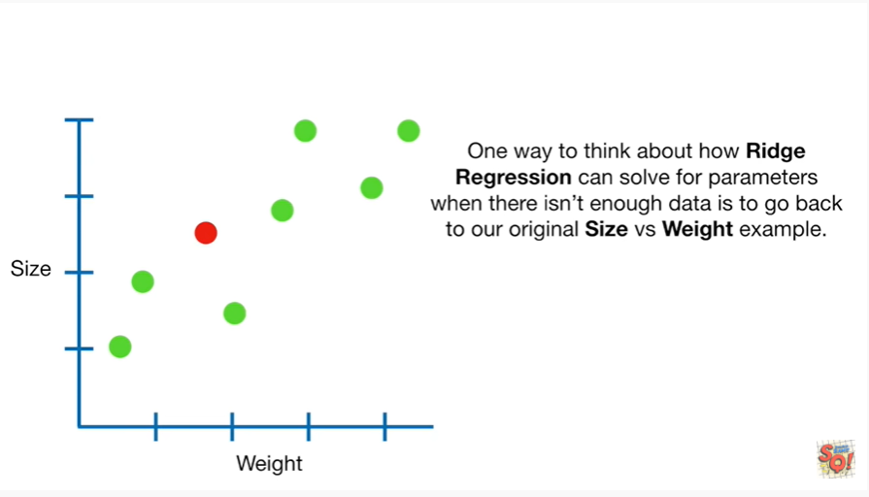

One way to think about how Ridge regression can solve for parameters when there isn't enough data is to go back to our original size versus weight example.

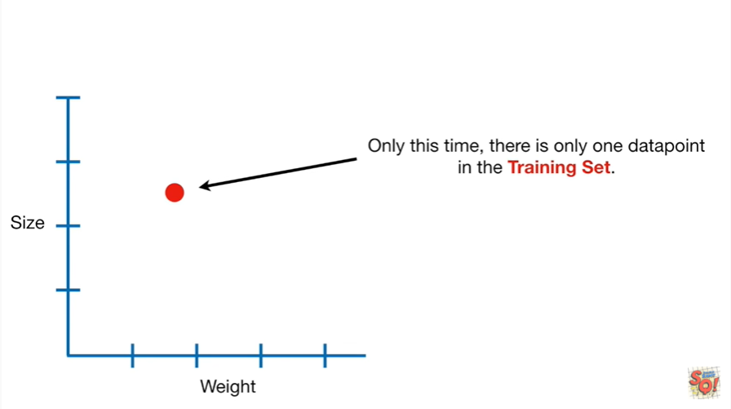

Only this time there is only one data point in the training set.

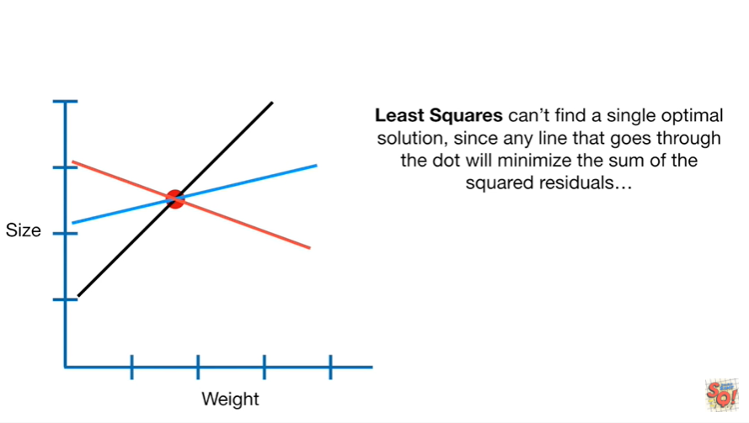

Least squares can't find a single optimal solution since any line that goes through the dot will minimize the sum of the squared residuals

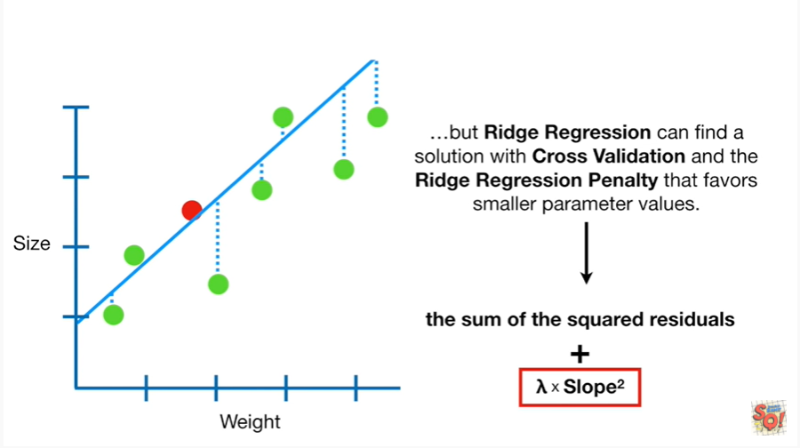

but Ridge regression can find a solution with cross-validation and the Ridge regression penalty that favors smaller parameter values.

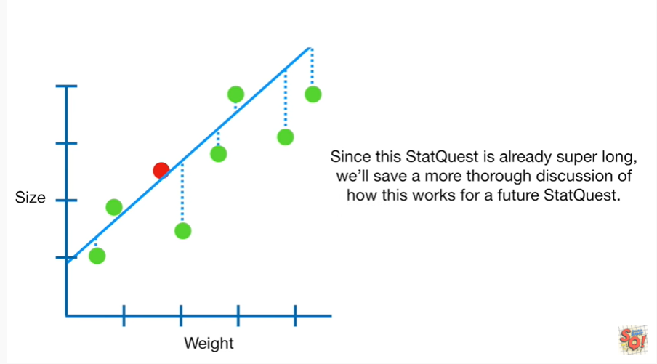

Since this statquest is already super long we'll save a more thorough discussion of how this works for a future stat quest.



Triple bam !!!



In summary.

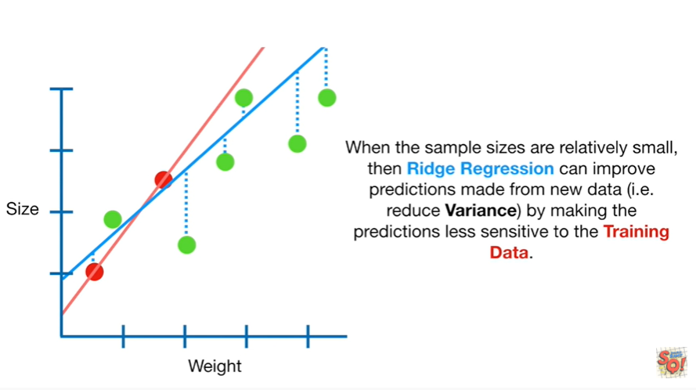

When the sample sizes are relatively small then Ridge regression can improve predictions made from new data ie reduce variance by making the predictions less sensitive to the training data.

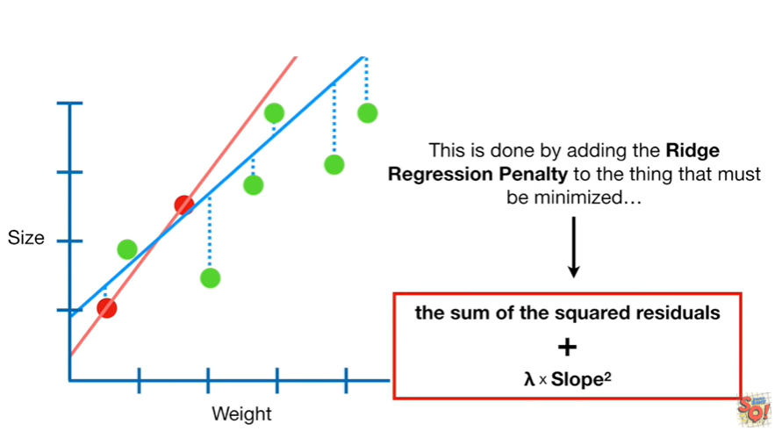

This is done by adding the ridge regression penalty to the thing that must be minimized.

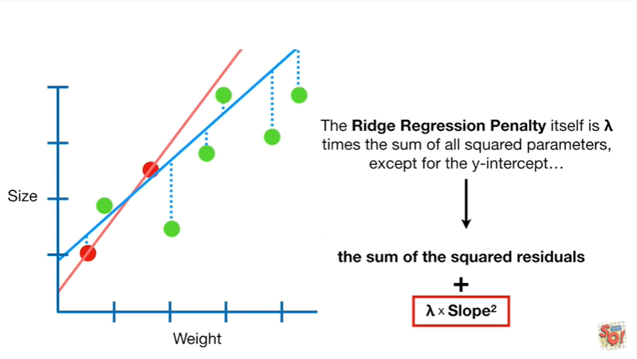

The ridge regression penalty itself is lambda times the sum of all squared parameters except for the y-intercept

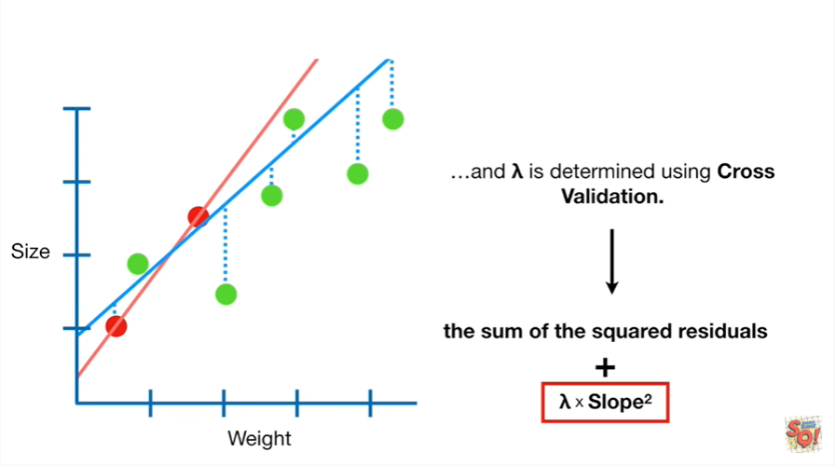

and lambda is determined using cross-validation.

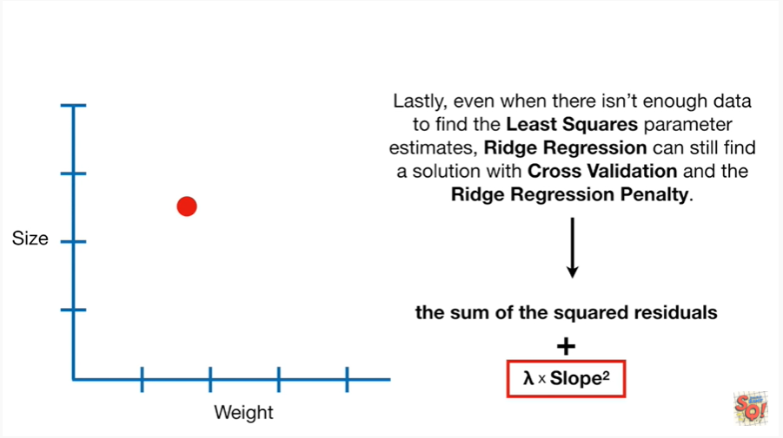

Lastly even when there isn't enough data to find the least squares parameter estimates

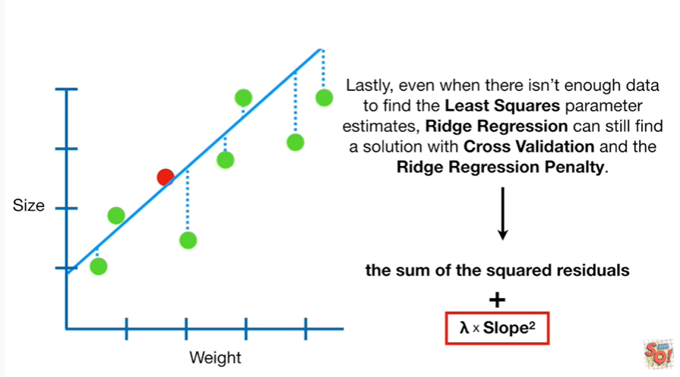

Ridge regression can still find a solution using cross-validation and the ridge regression penalty.